# Midterm Report Anthony Morgan

## Project overview This project is a full stack web development project aiming to have a front and backend that pulls from a database. The frontend will consist of five pages. The first page will allow you to input your name and save it so that you can have the test that you create attached to your name the next page is the test creator page it will allow you to create the test it will have 10 questions and four answers per question you will type each question and answer in but click on what answer you deem correct. the third will allow people to take the test that was just created they will input their name so that their results are connected to it after completion the next page will make test taker see the results of their test in percentage form pulling the freshly created test results from a database. while the fifth page will allow the creator to see the results of the all the people that took the test. Initially I planned on using the mern stack but after researching what is more valuable in the area I want to live in, postgre sql is the option that I will use because it is more valuable In Atlanta and its metro. The coding technologies I will be using are vscode PostgreSQL ,react , JavaScript ,and expressjs

### Frontend namepage overview

The name page will have instructions on how the website works as well as a way to enter your name in order to start creating a test it will also not go to the next page without you putting in your name. After submitting your name, it will be saved to a database and stored so that I can connect the test that will be made to the creator of said some of the front end will initially be made in JavaScript and then rewritten with react

### Frontend testmakerpage overview

On the test creator page there will be 10 questions that you have to use. And four potential answers that must be filled out with one correct answer that you will be able to click on to notify the webpage that the answer chosen is the correct answer. All of this information will save to a database after you submit it. This database table will separate the name, questions ,answers and correct answer and then transfer the test maker to the results webpage.

### Allresults webpage overview

This will be the webpage that the creator is sent to right after they finish making their test. It will have a link that they can send to others that would allow them to do the test and a box for results that can be seen after others complete the test clicking refresh after a person completes the test will autopopulate their results . in order to do all of this it will have to get a link that is automatically created from the backend and pull the name and test results from the database showing all the completed test results.

### TestTaker Webpage overview

This page is where people will go to complete the test that they were sent it will have a section to enter your name as well the 10 questions. After answering all the questions, the taker will submit it and it will save all of the information to a database a give them a grade after completion, that grade will then transfer to the results webpage.

### Testtaker results webpage

This page is what the test taker will see after getting their results I will need to pull the name, and the correct and incorrect answers as well as make a formula to show the grade in a percentage

### Backend overview

The backend will be made in node.js and express js it will have to do many things. First a server will have to be made in this server there needs to be ways to push information into a database and get information from a database. That’s not all there will be a lot of functionality that JavaScript will need to do like the ability to choose what answer is correct as well as the slight changes in colors after hovering over something. I will also include the database in the backend , I will need to create multiple tables one for names of the test creators another for the actual test, finally one with the names and results of the test takers I will also have to initialize a lot of PostgreSQL requirements within the terminal . in conclusion with the backend I will have too pull and put information into a database while also having separate JavaScript file if I don’t put them in the html code hemselves

Learning objectives  
  
Advanced JavaScript

While coding with JavaScript I learned how to send and fetch data from a database and display that fetched data I also learned how to dynamically create the same object over and over with arrays. I learned how to stop users from going to the next page without completing a task. The other simple javascript stuff I already knew but when it comes to servers I was a complete novice. I had to learn how to start a server how to save static files get them from a specific folder using apis and serve them to the database as well as how to connect my database to the server. How to connect the database to a specific port and even initialize the database g

React  
React was a difficult thing to learn the main reason being there are so many things to compile and initiate depending on the changes. In my opinion it seems inefficient and actually made me look up different options for building ontop of javascript like angular which seems more together and doesn’t need the extra compiling or downloads from a library bit it does require typescript. Regardless I learned how to implement react into my JavaScript and how to use the server terminal within the react project to help me fix my issues.

Postgresql  
With postgresql I knew how to do most of the stuff already saving data and updating tables with lines of codes the only thing I really learned is how to use postgre sql as opposed to mysql but the skills were very similar so im not sure I can say that I learned anything besides how to safely delete a tables’ data and how to connect a database to a certain port

Preliminary  
These are all my files they are put in a specific order with html being at the top and JavaScript and CSS being below this helps with a cleaner and more efficient transfer of data.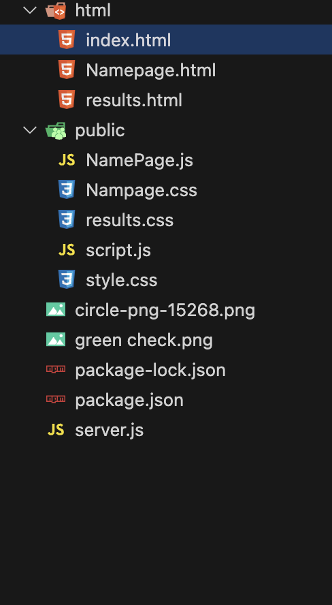

## Frontend

## The start

All fonts will be cambria

All images will have a transparent background

### 

I start off by Clicking “!” And it will auto populate the html skeleton

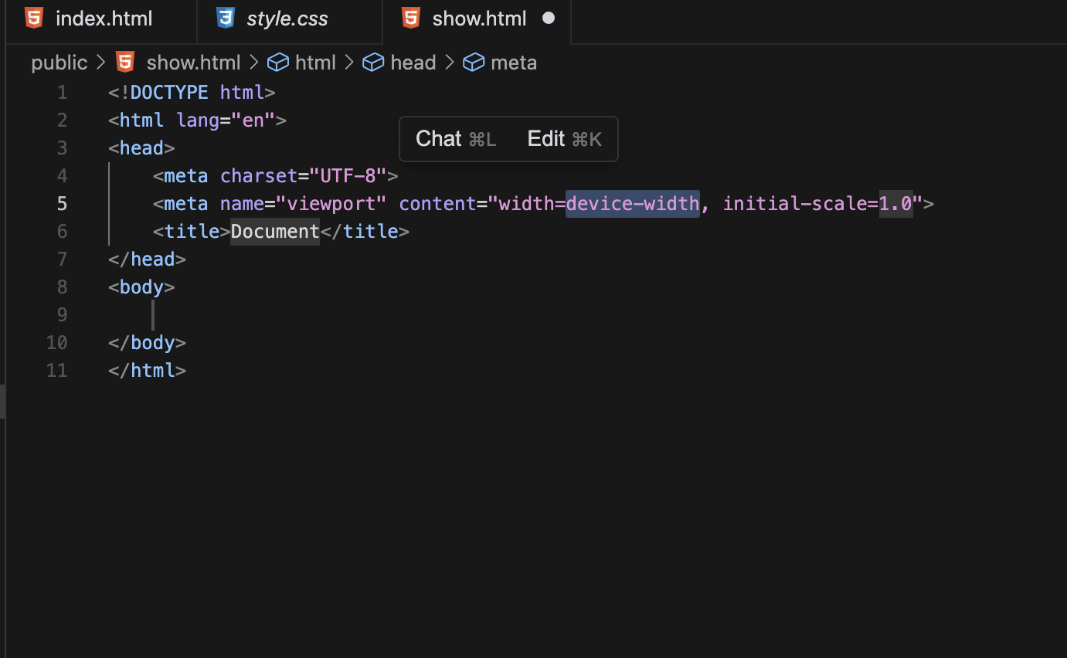

I then Linked the future css and JavaScript content to the html file so that they can show once completed CSS is linked first so the changes can load before the content actually pops up. JavaScript under the header so that the added functionality doesn’t slow down the content loading process

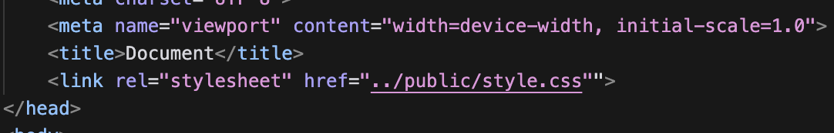

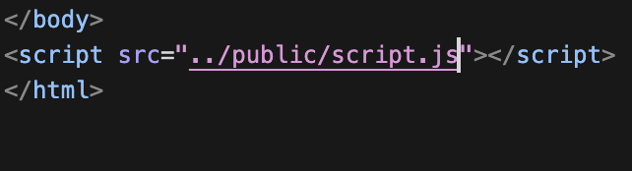

### Background

### 

I Used the background line to create a linear gradient that translates two complementary colors. complementary colors to provide more of a pop of color being more visually appealing

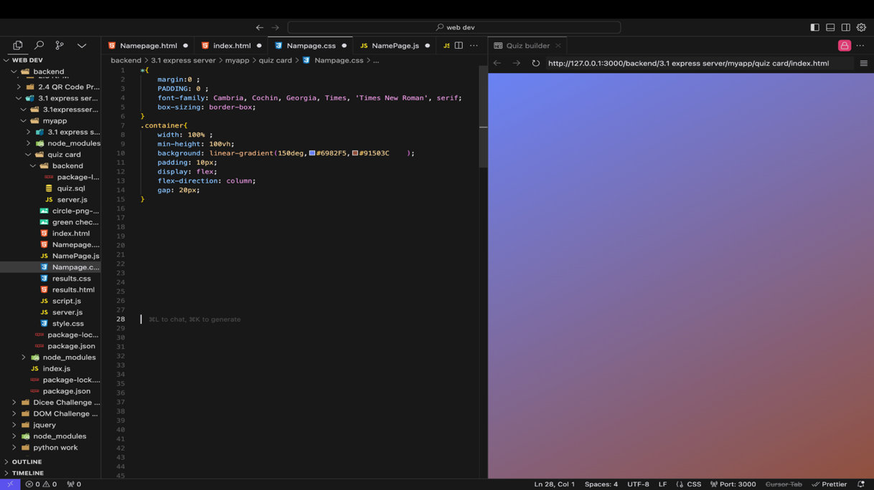

### Quiz page

#### Giving classes

Next I Created classes and placeholders that give the cards their own identity and allow for words to be typed into them with an input function. The input function created the highlighted area with the other things being created with basic html.

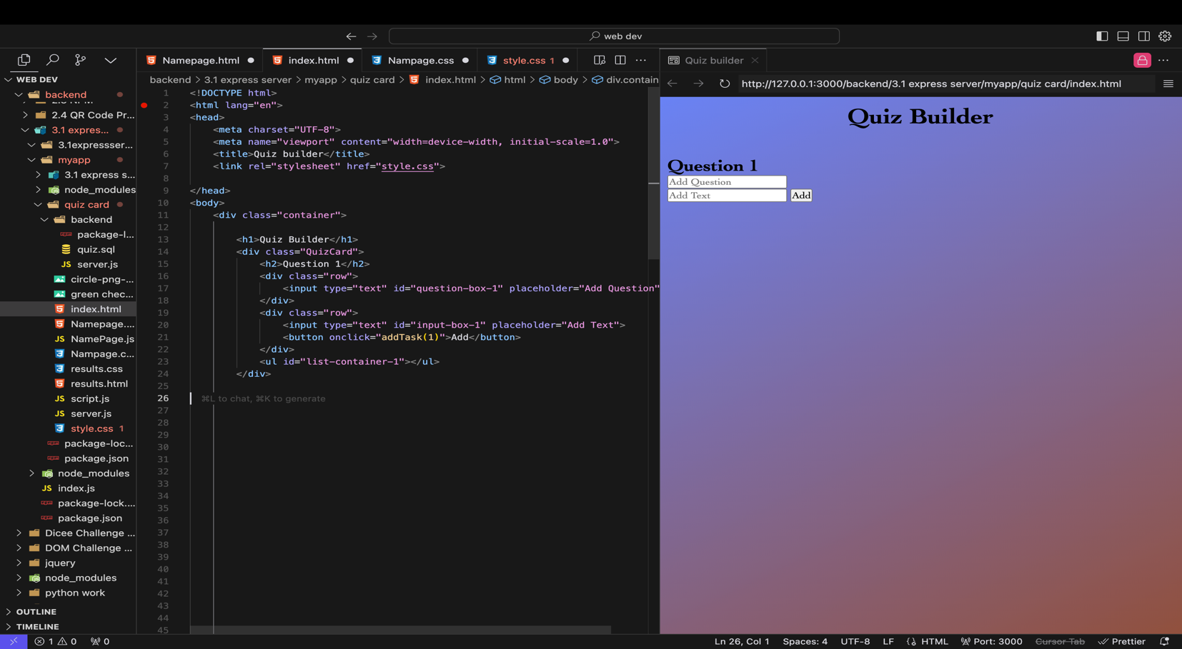



#### Creating the card

Add a white color within the quiz card container this adds obvious difference to the background making the quiz card look like a digital flash card. Also change the display type to flex this allows items to be more flexible this along with flex direction will place the card in the middle.

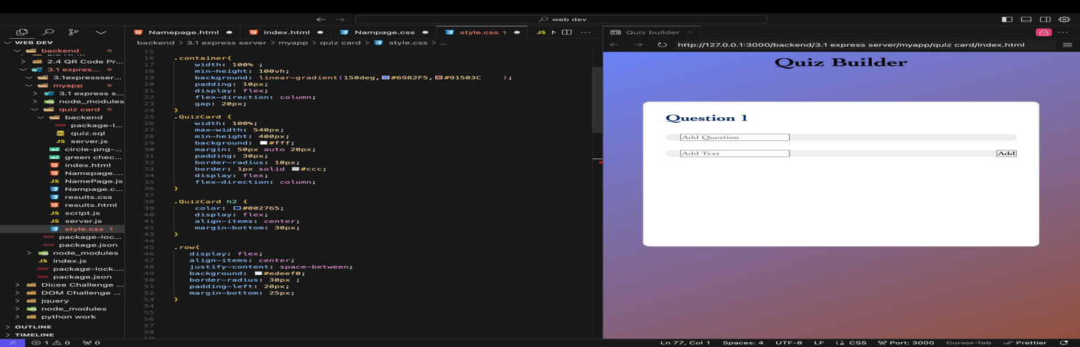

Fix the input section to be more visually appealing make the background transparent and add padding also change the add button make it bigger a different color and rounder by using the border-radius function

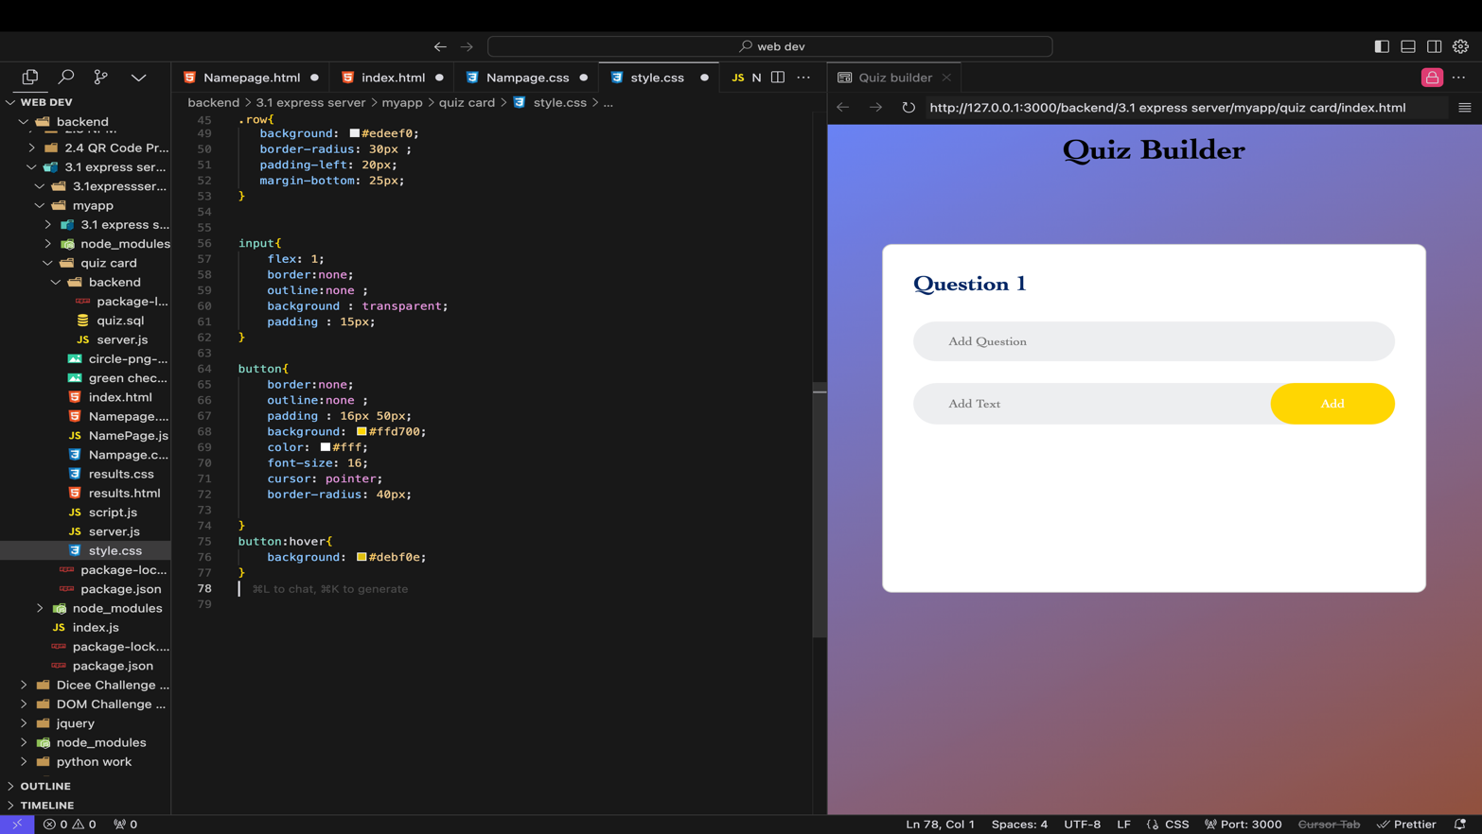

Use the append function this allows what you type in the add text section to be added below in the quiz card it will also append a checkmark to the option that you decide is correct

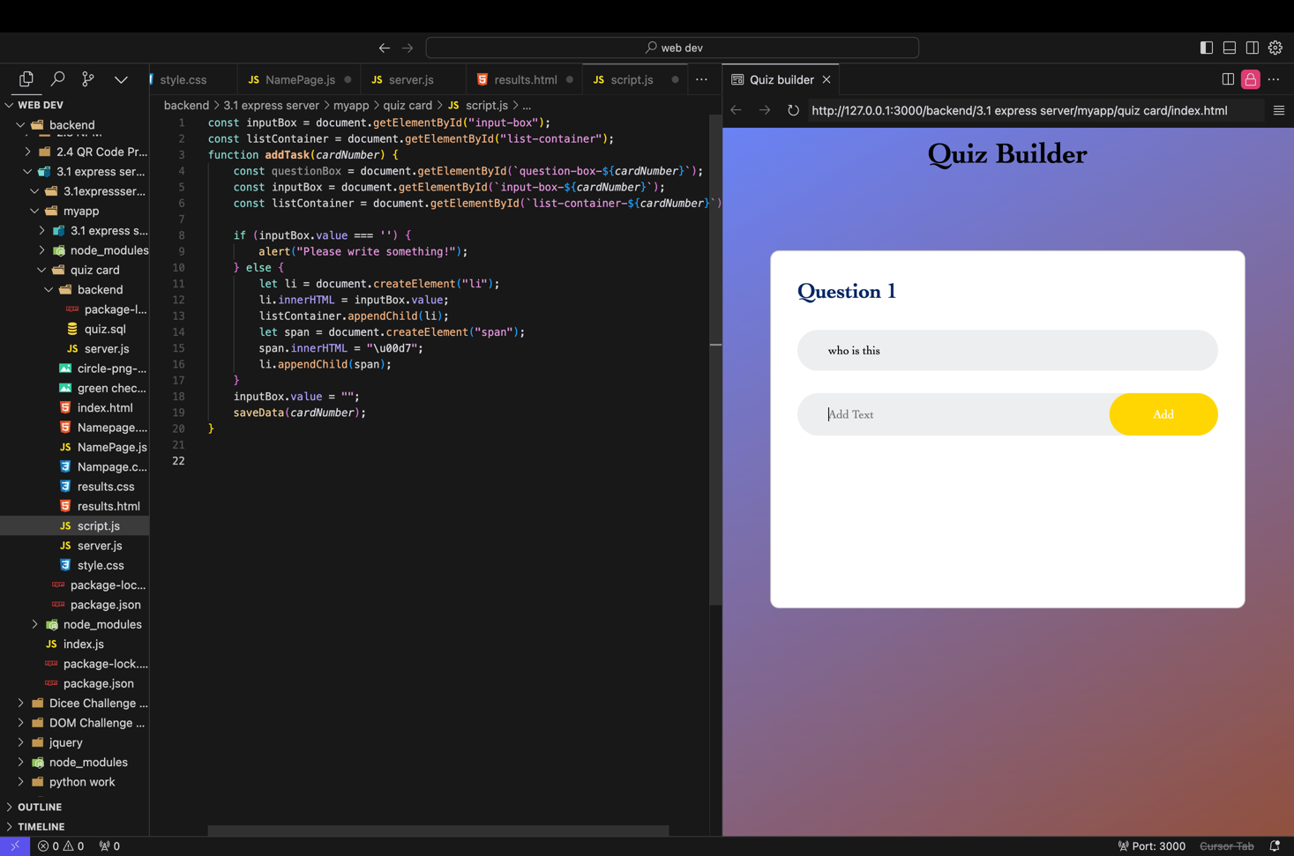

Clicking the 3 horizontal lines in the preview side will open the file onto a webpage

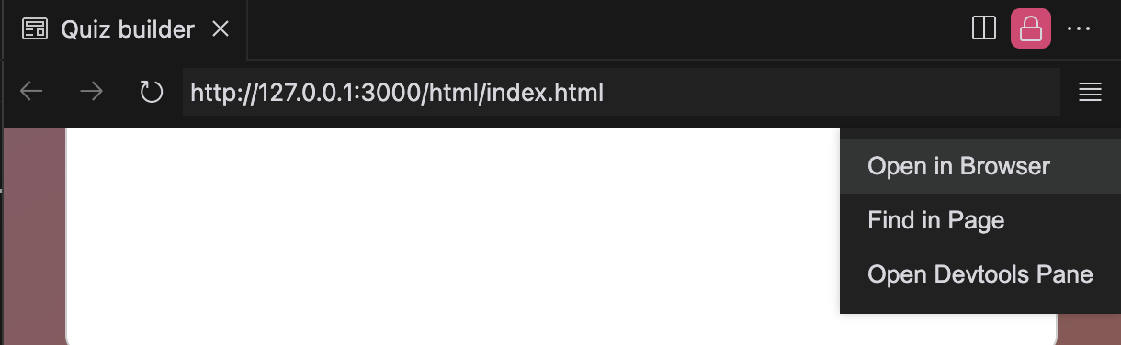

The red circle and green check are now added. The highlighted area is the opened file on a webpage this changes once connected to a data base.

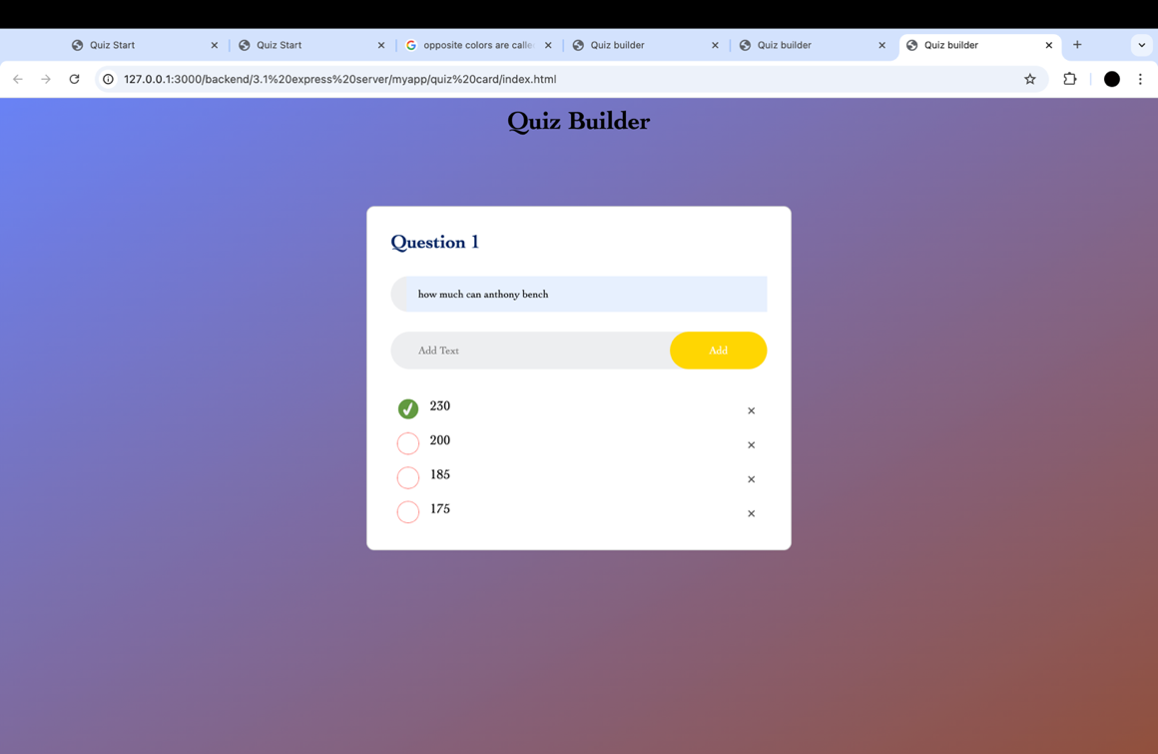



This Css code adds the green check and the red circle to the options the two png’s must be transparent backgrounds.

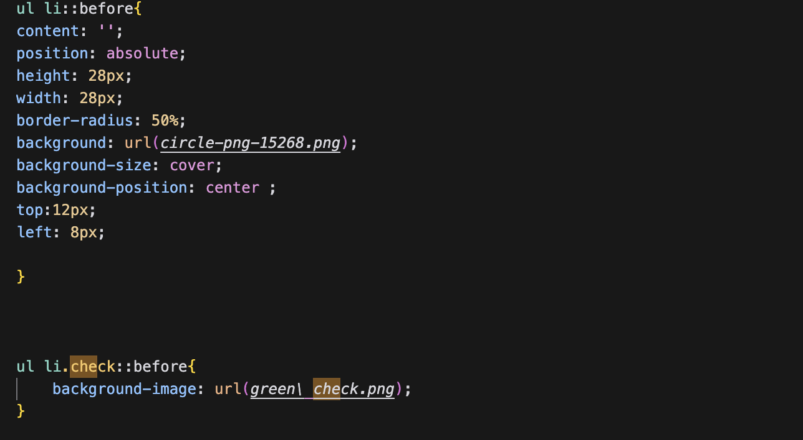

#### Finishing the card

Copy and paste the quiz card 10 times so that there can be 10 questions for others to answer.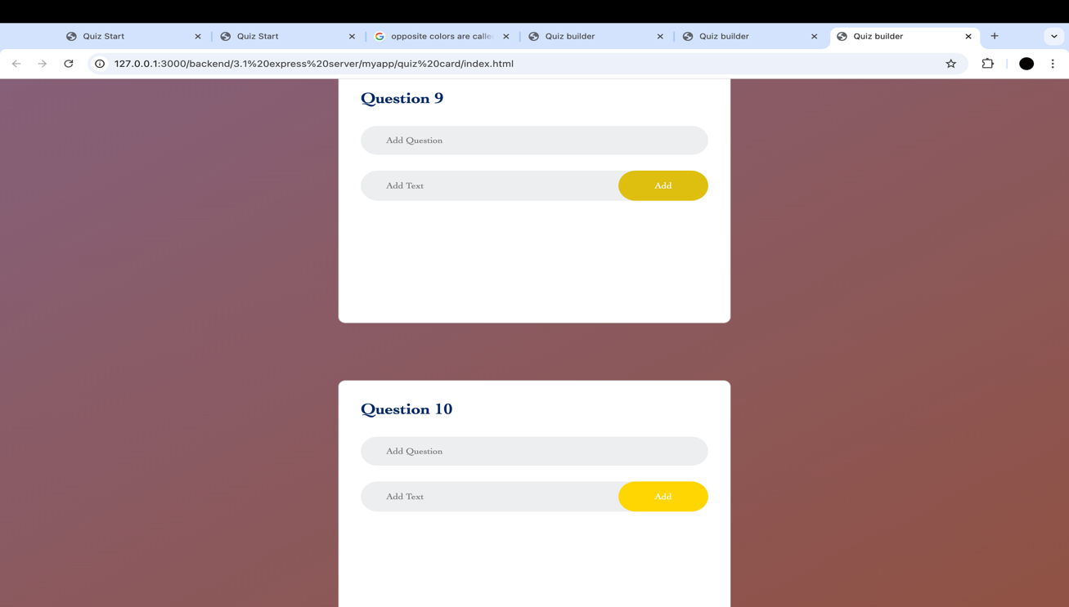

After doing this I made sure to go to the html and change the id of each card accordingly I’e the sixth question box will be id=”question-box6”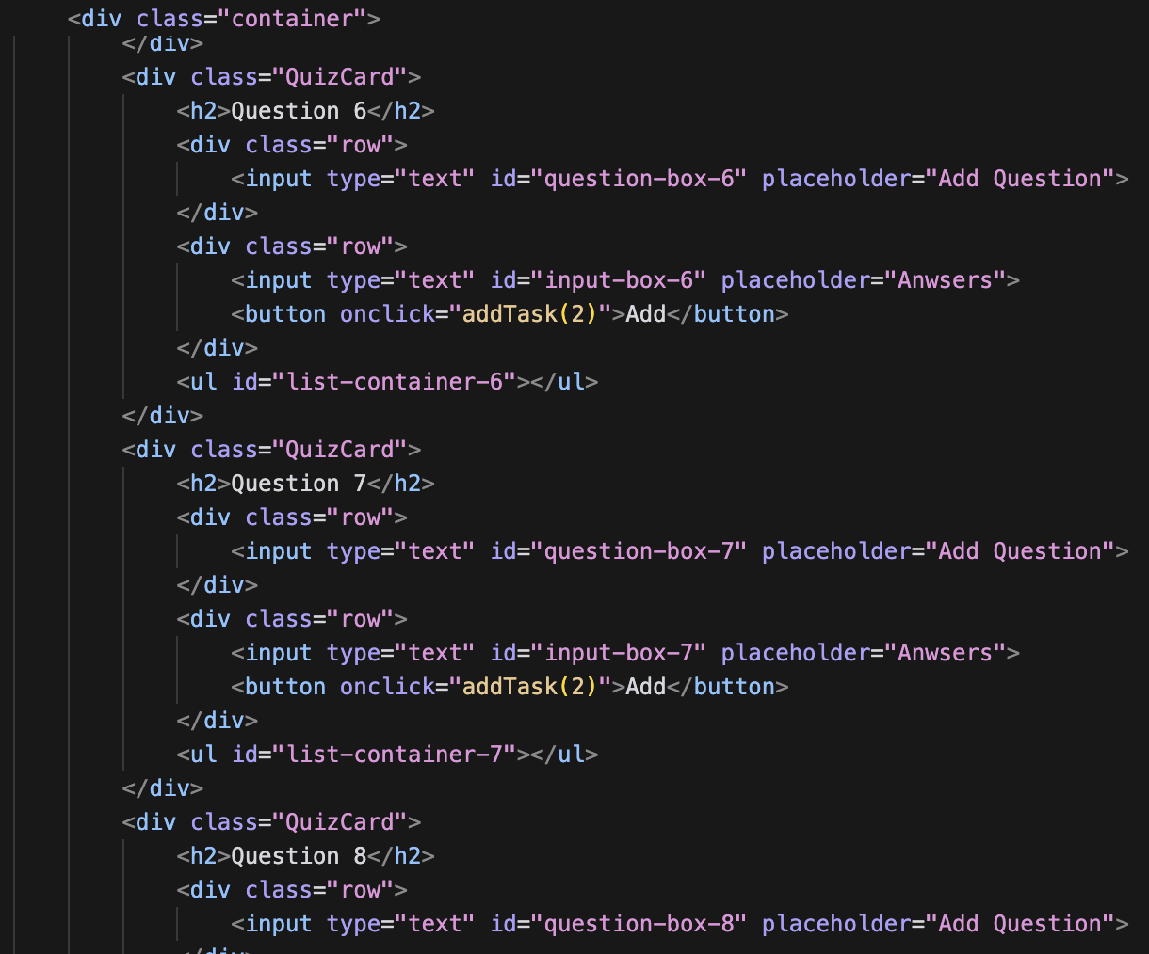

Create a function called addTask. This function will create a popup if there is a blank answer but the add button was clicked, it will notify you to write something there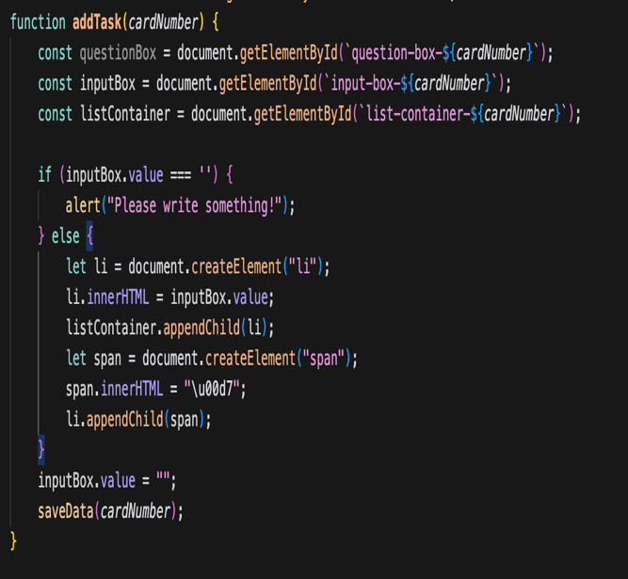

Like this

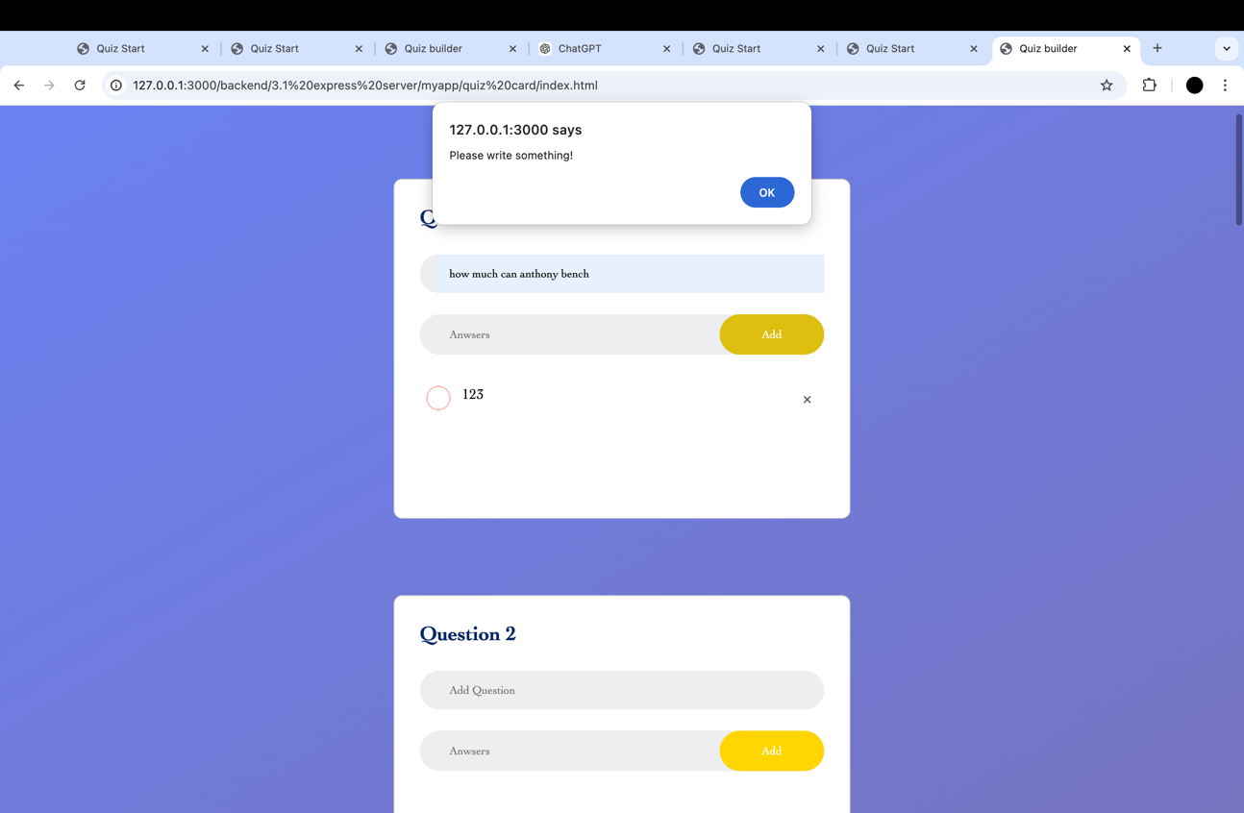

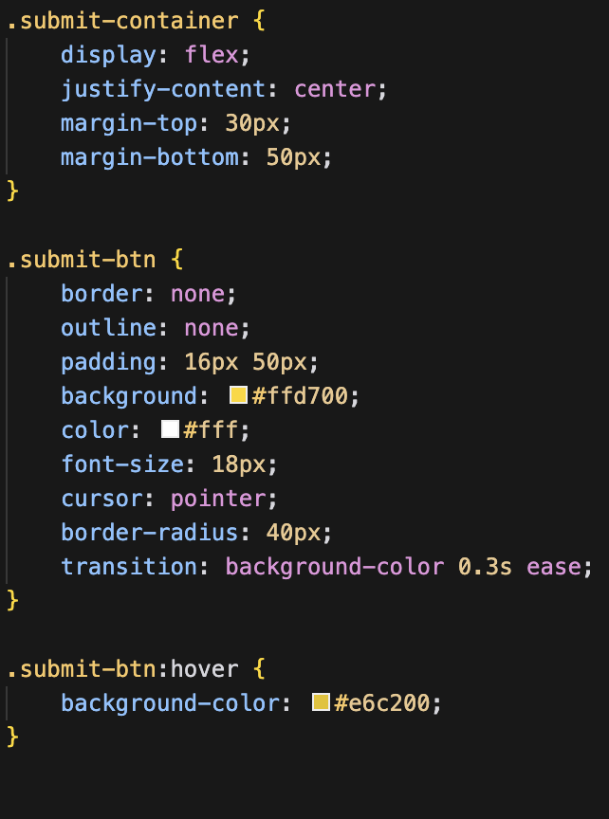

This code created a submit button at the bottom of the page. First I had to create a container so that I could move the button to the bottom and middle then I added the previous buttons CSS to this one.

### Changes made to quiz creator page

Instead of being inefficient and using the same quiz card that is copy and pasted 10 times I created a function that creates the card and gives me 9 extra copies .  
  
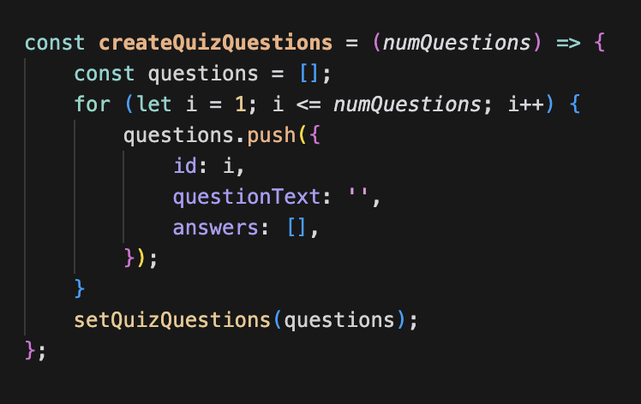

### Start quiz Name form

#### Name form

Copy the quiz cards html and the css background delete the second input line in the html code and change the placeholder text to “enter your name.

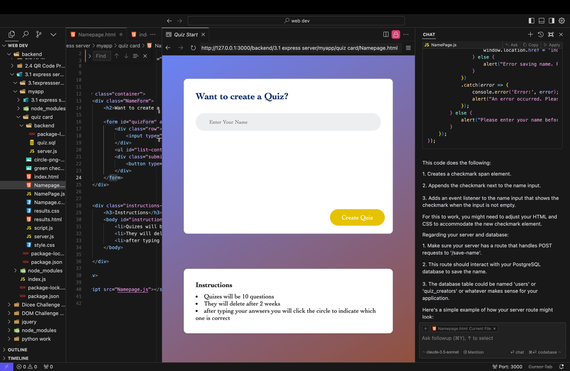

Move the create quiz section to the bottom of the form this code changes its location to the bottom right and once you hover over it the color will lighten slightly. once you click create quiz it is supposed to bring you to the quiz card page and save your name to a data base.

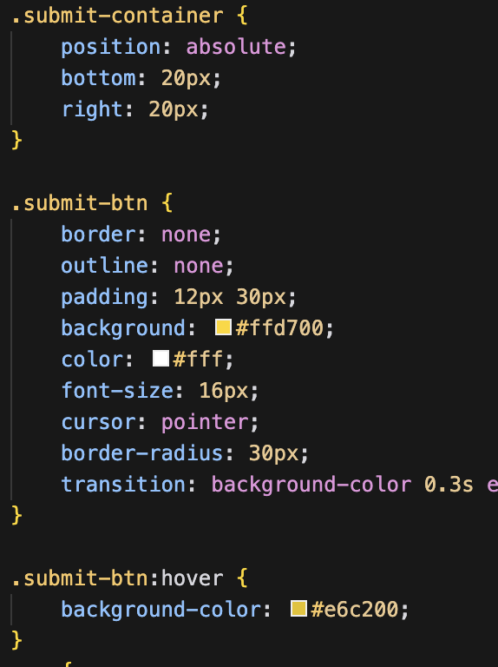

#### Instructions box

Create a class called instruction box. I used css to change the color and shape of the box and I put it in the middle right below the name form and rounded the corners

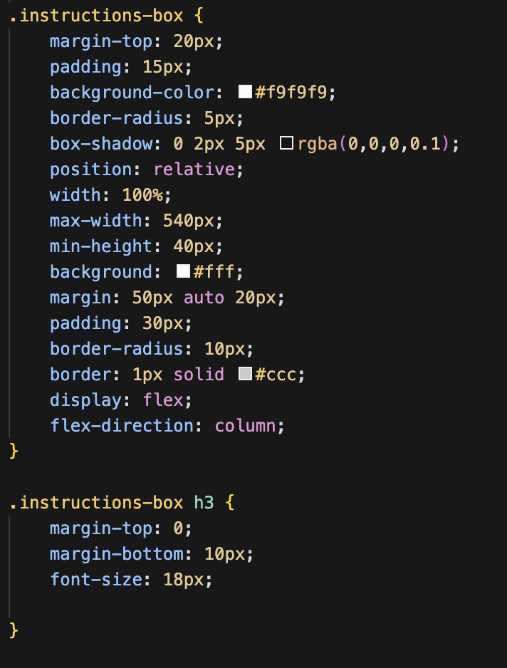

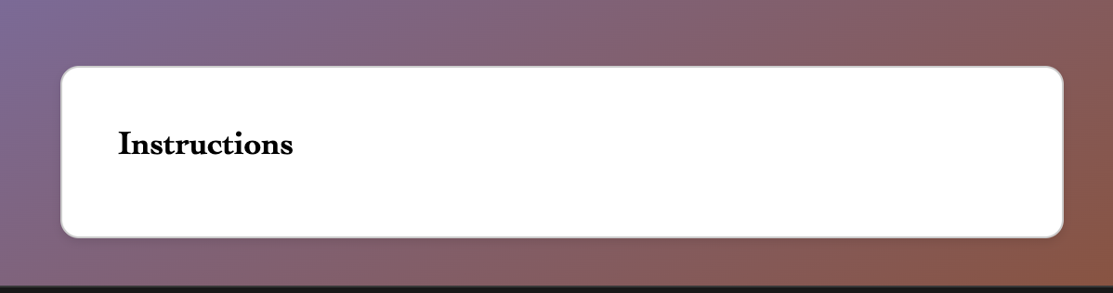

The HTML for the instruction box I used <li> to create the bullet points and make it look more organized

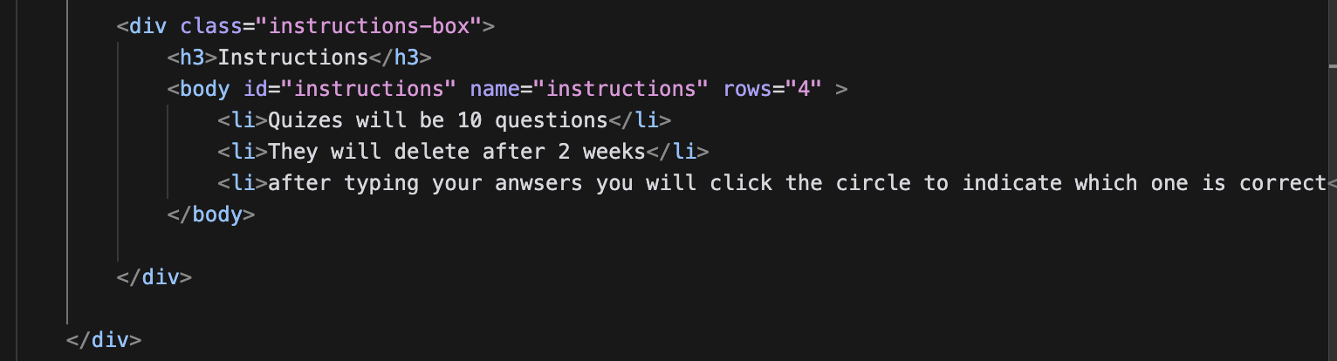

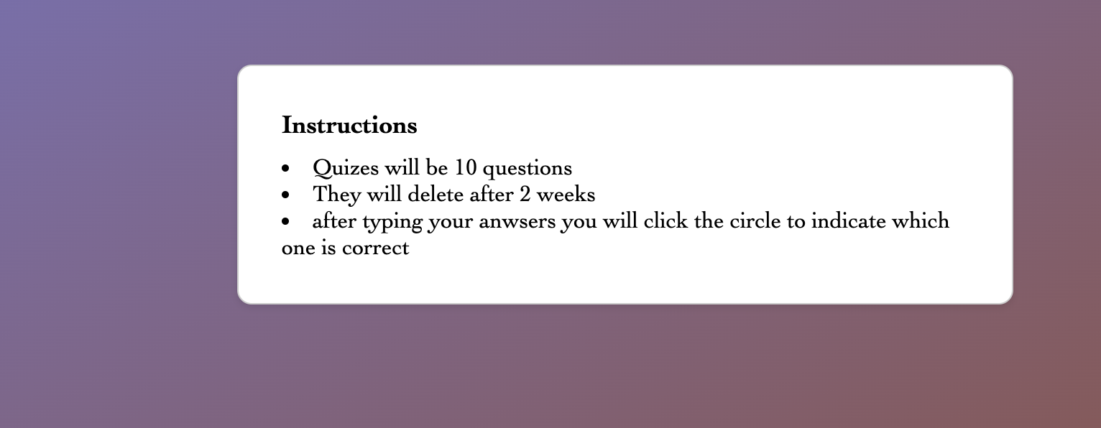

### Results page

#### HTML

In the results page I created a moving gradient that switches from green to red this indicates wrong and right.to do this I created 3 classes called wave.

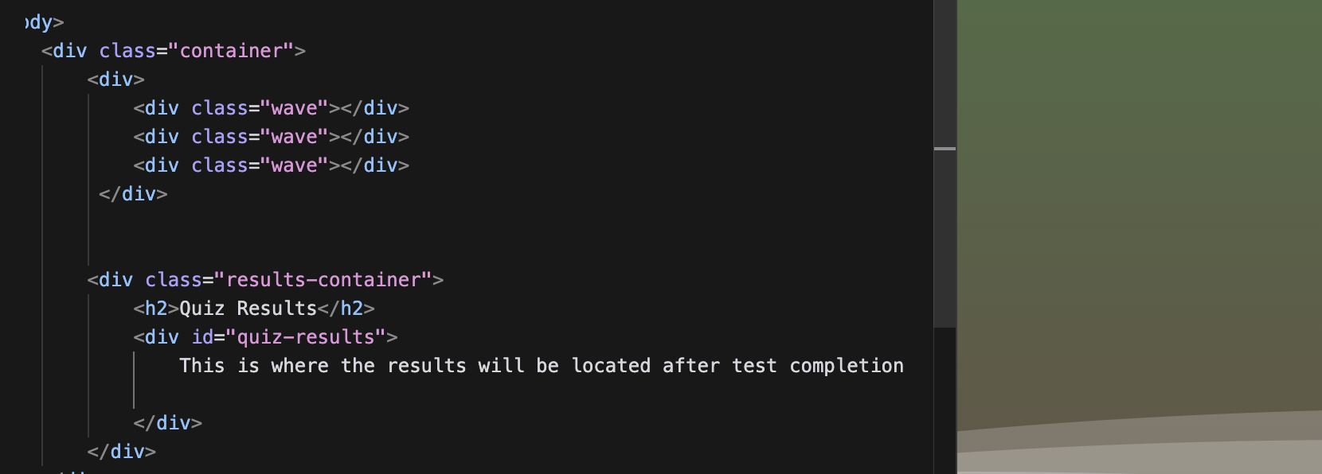

#### CSS

Gave the background its own linear gradient

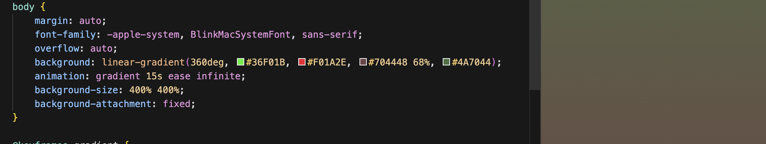

Gave each wave its own color and movement within the container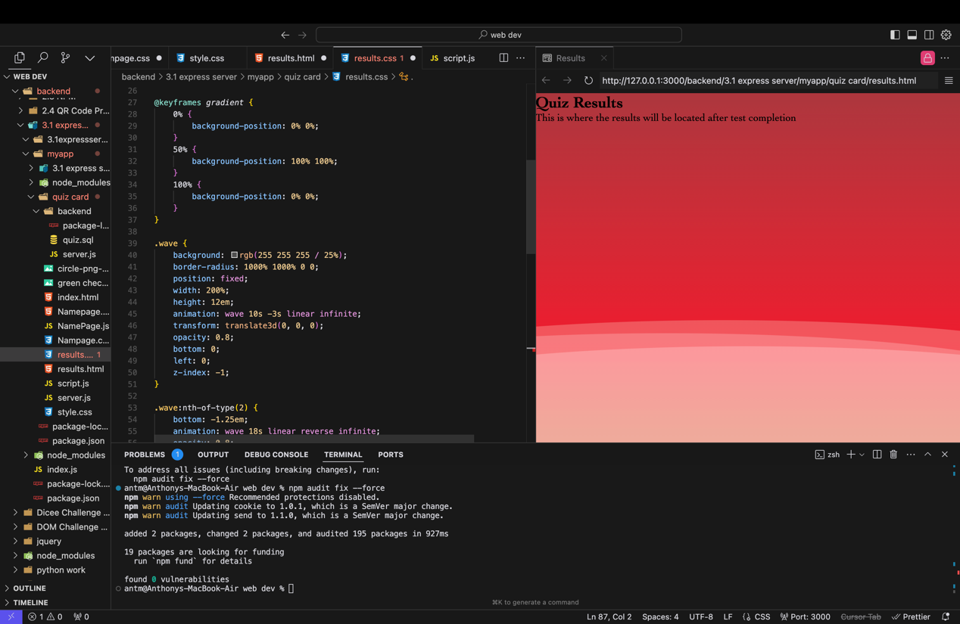

Added keyframes that change allowing for the colors to move and transform

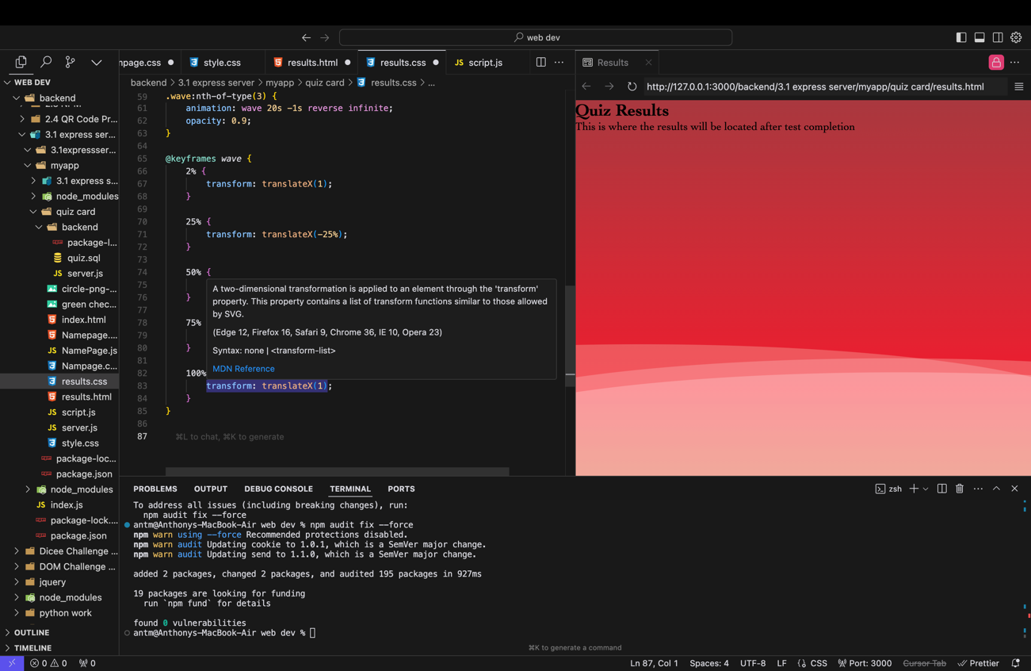

#### Results section

Next create a container that will hold the results. 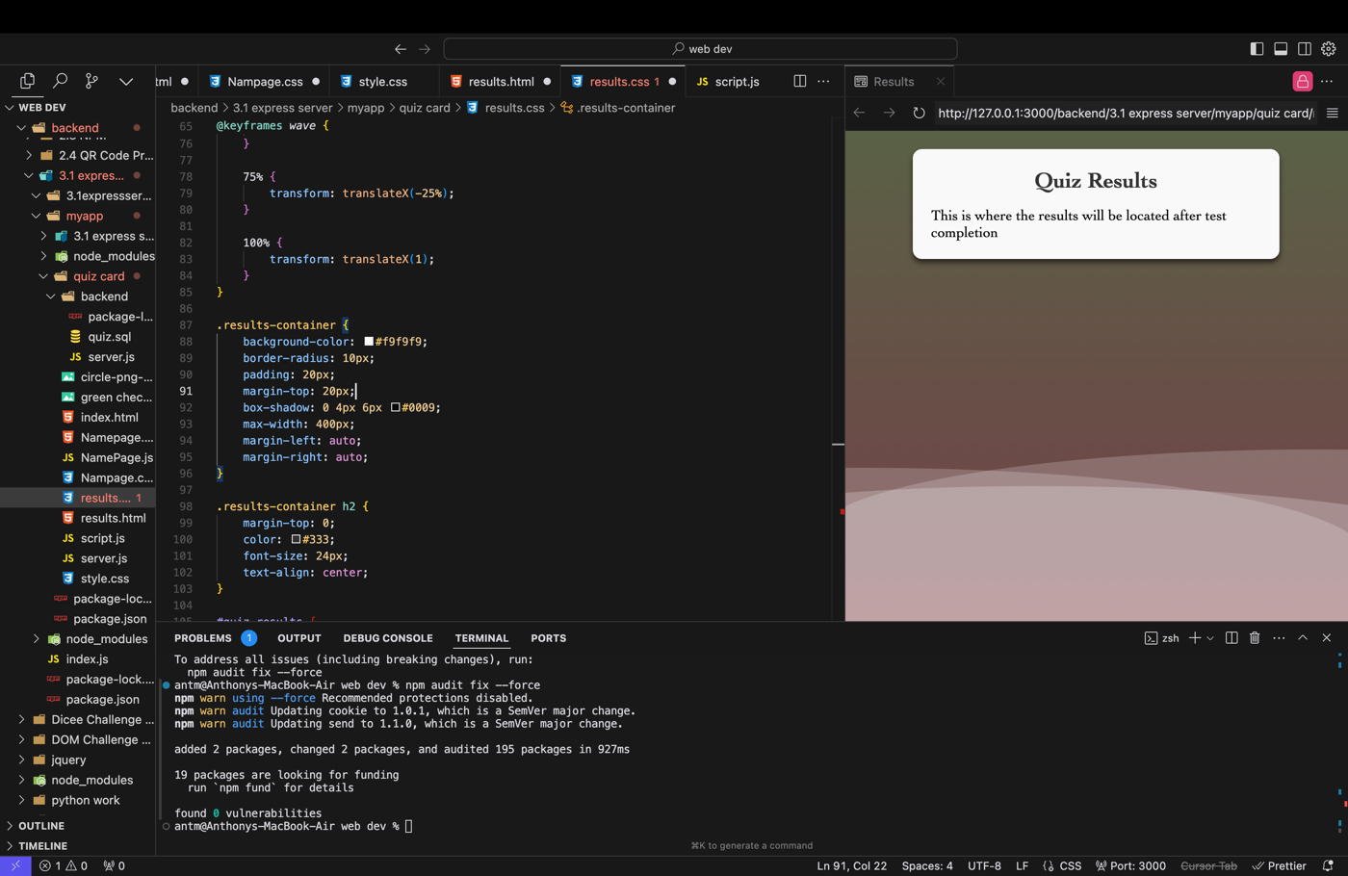

Add a container within the container to make the results placement more visually appealing once taken from the database.

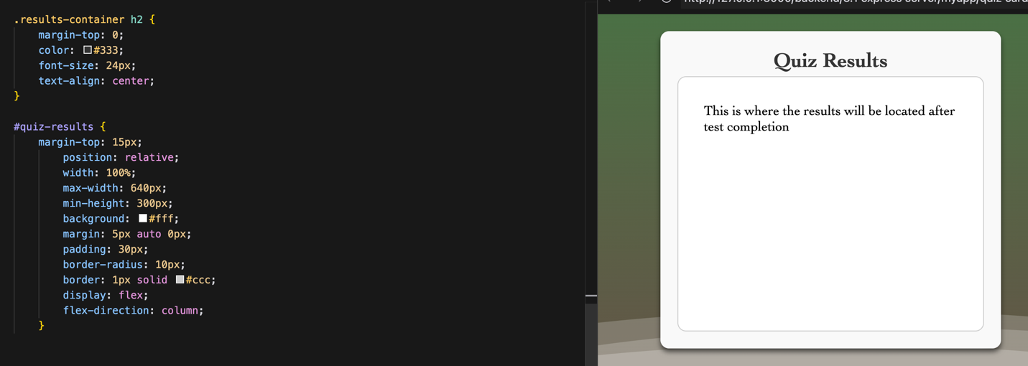

### Allresults page

The all results page will show the grades of the people that created the test you created   
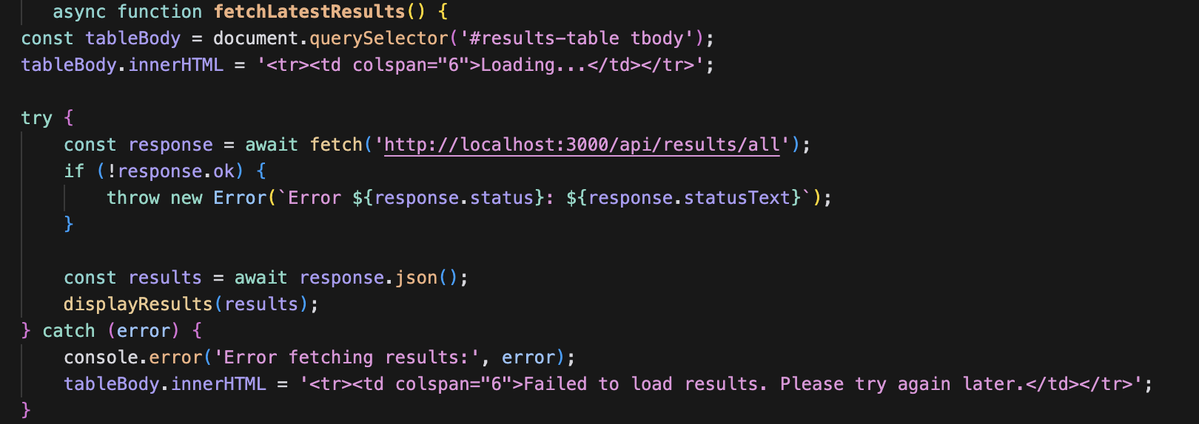

This code fetches the latest results from from the server and after fetching puts the results in the created html table   
  
  
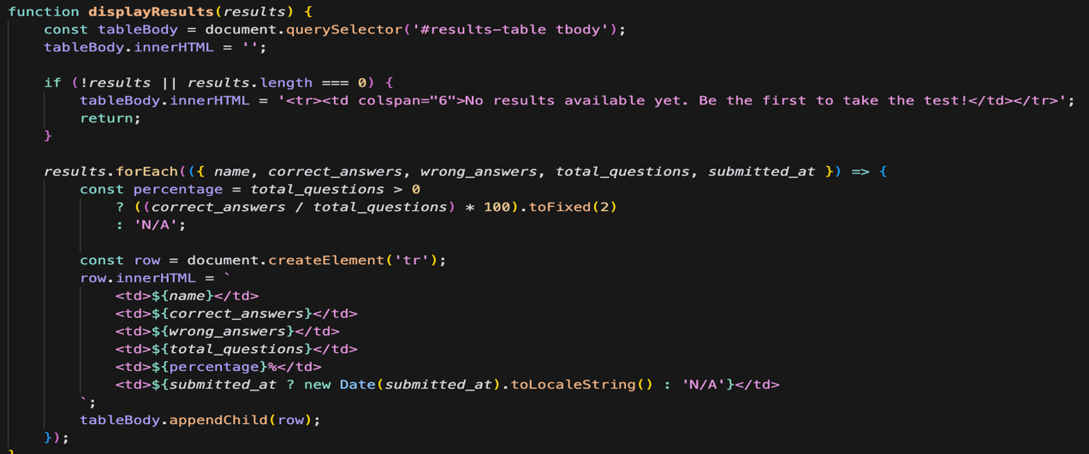

This organizes the results within a table and give a percentage grade.

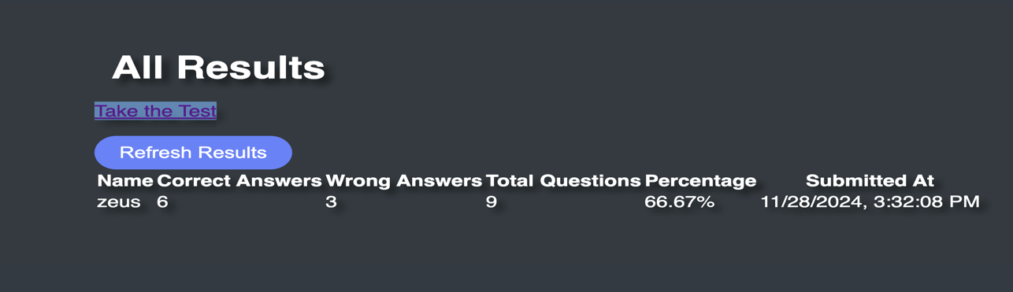

## Backend

### Quiz maker backend

Add an event listener once something is added to the list of possible answers you can click it to add a check to represent the correct answer   
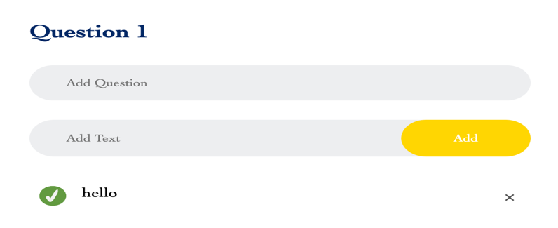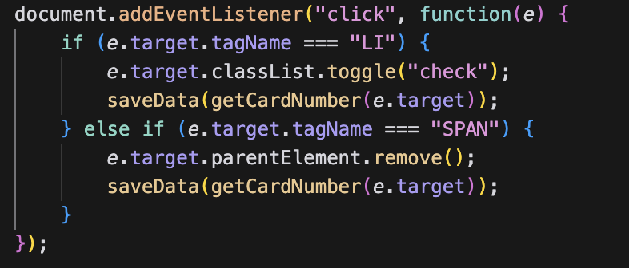

Before we get to the data base portion, we will simulate saving the name information to the console if there is no name you will be asked to enter a name if you enter a name you will be able to build your own 10 question quiz

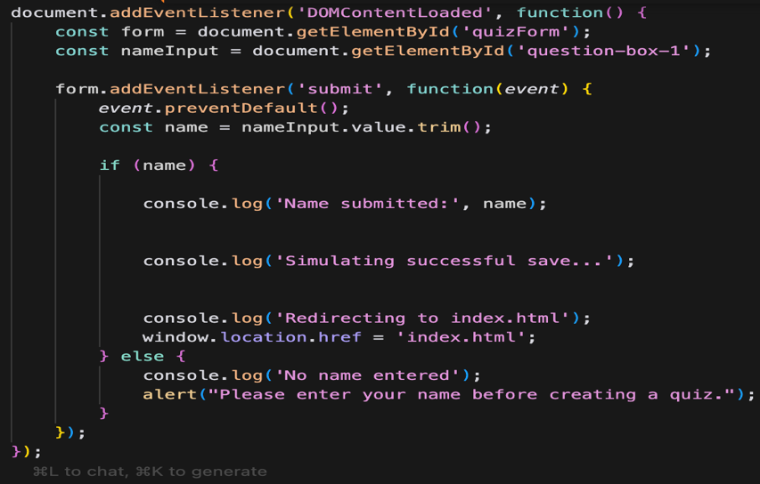

### Name page backend

This code allows for the JavaScript to be more easily manipulated later on as well as assigns name Input to question box one

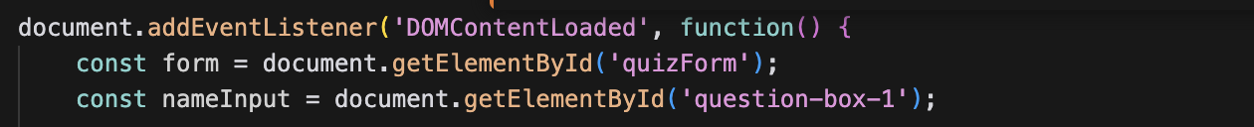

This part of the code checks for if the name portion of the start quiz form is filled while post is an api request that saves the name to the server   
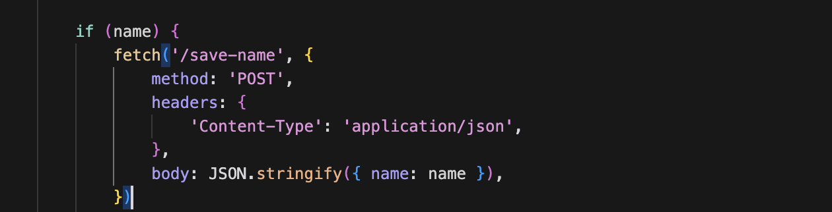

This saves a name if the space is filled if not it will send a request that asks to enter a name before creating a quiz.

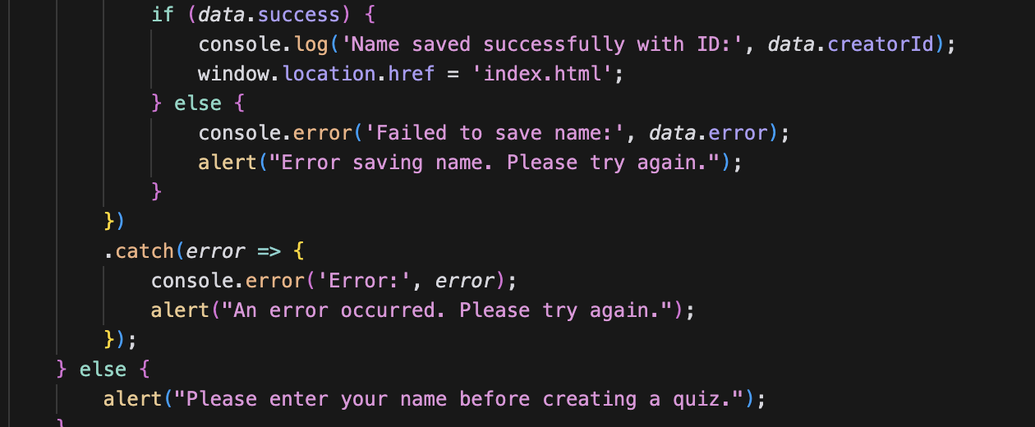

After clicking create quiz without a name I was told to fill out the field this was done with the code above  
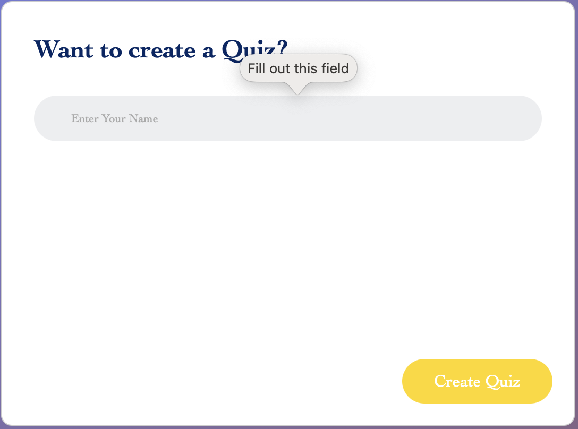

### Server

I Initialized and installed posgres and download the json package through the terminal for this project by typing what’s below

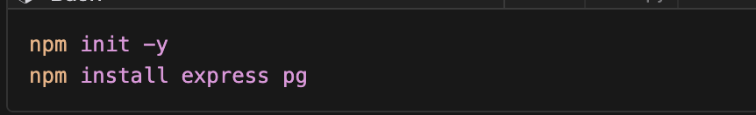

Each line one by one

const express = require('express');// This line imports the express.js framework

const { Pool } = require('pg'); this line imports the pool class from post gres

const bodyParser = require('body-parser'); this line parses postgres data

const app = express(); this will help express handle https request

const port = 3000; this will define what port express will run on

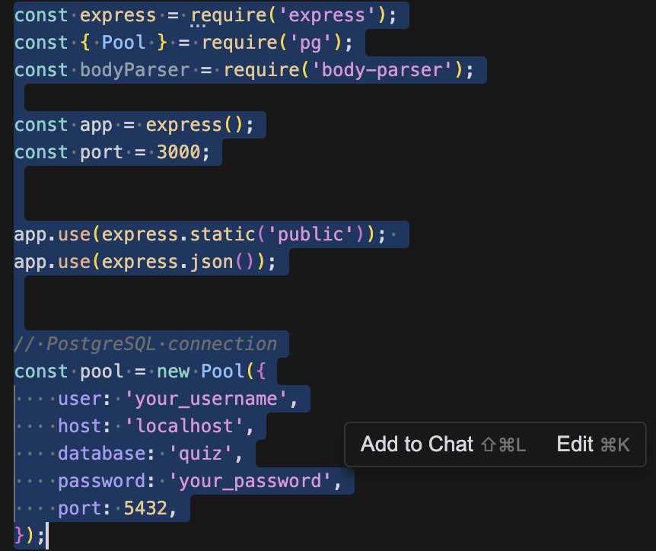

This give a direct connection to the postgres sql database the user name host databse name password and port is needed .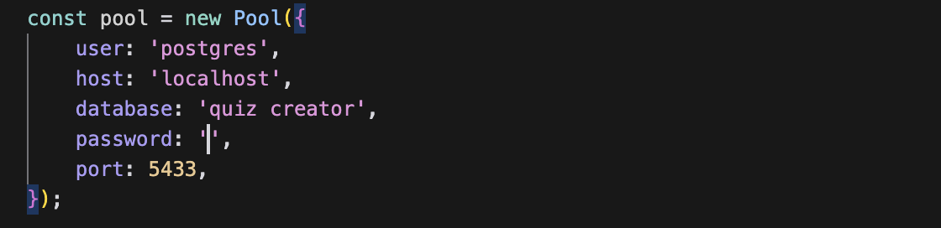

This code Gets the starting html file and connect it to the server this will allow the file to be ran with the local host 3000. Next create an sql query that creates a table in postgres if one is not already created. This will store the names of the quiz creators.

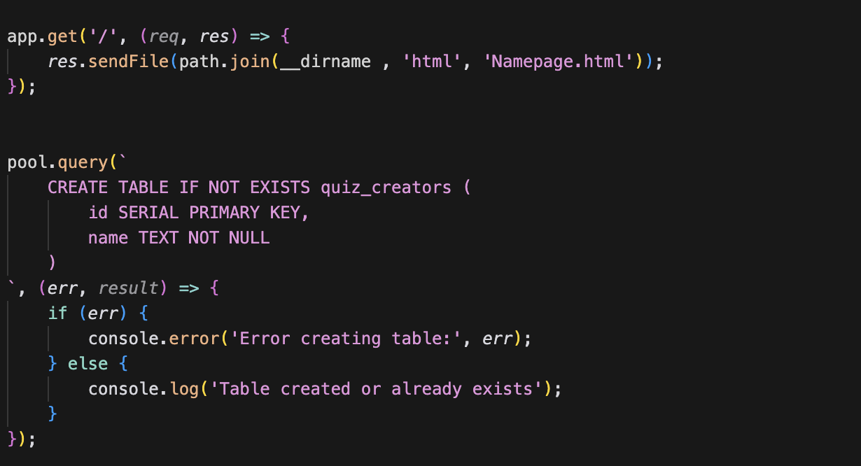

This is the connection that will Start the server on the local host

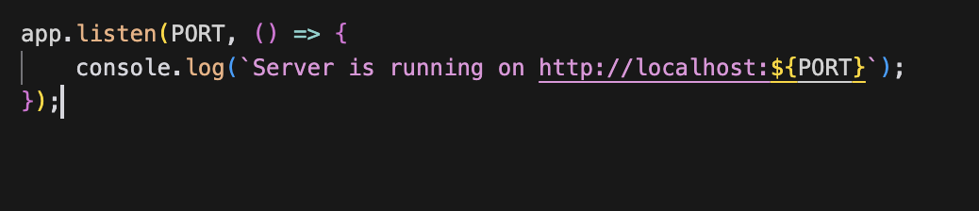

This code in the terminal officially gets the server running ans shows that the table Quiz_creators already exist.

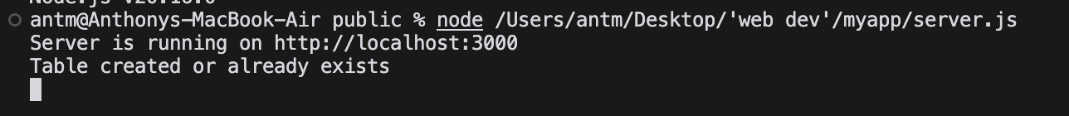

Upon connecting there will be no CSS there is a reason for this in the server the html file pathe was already initiated

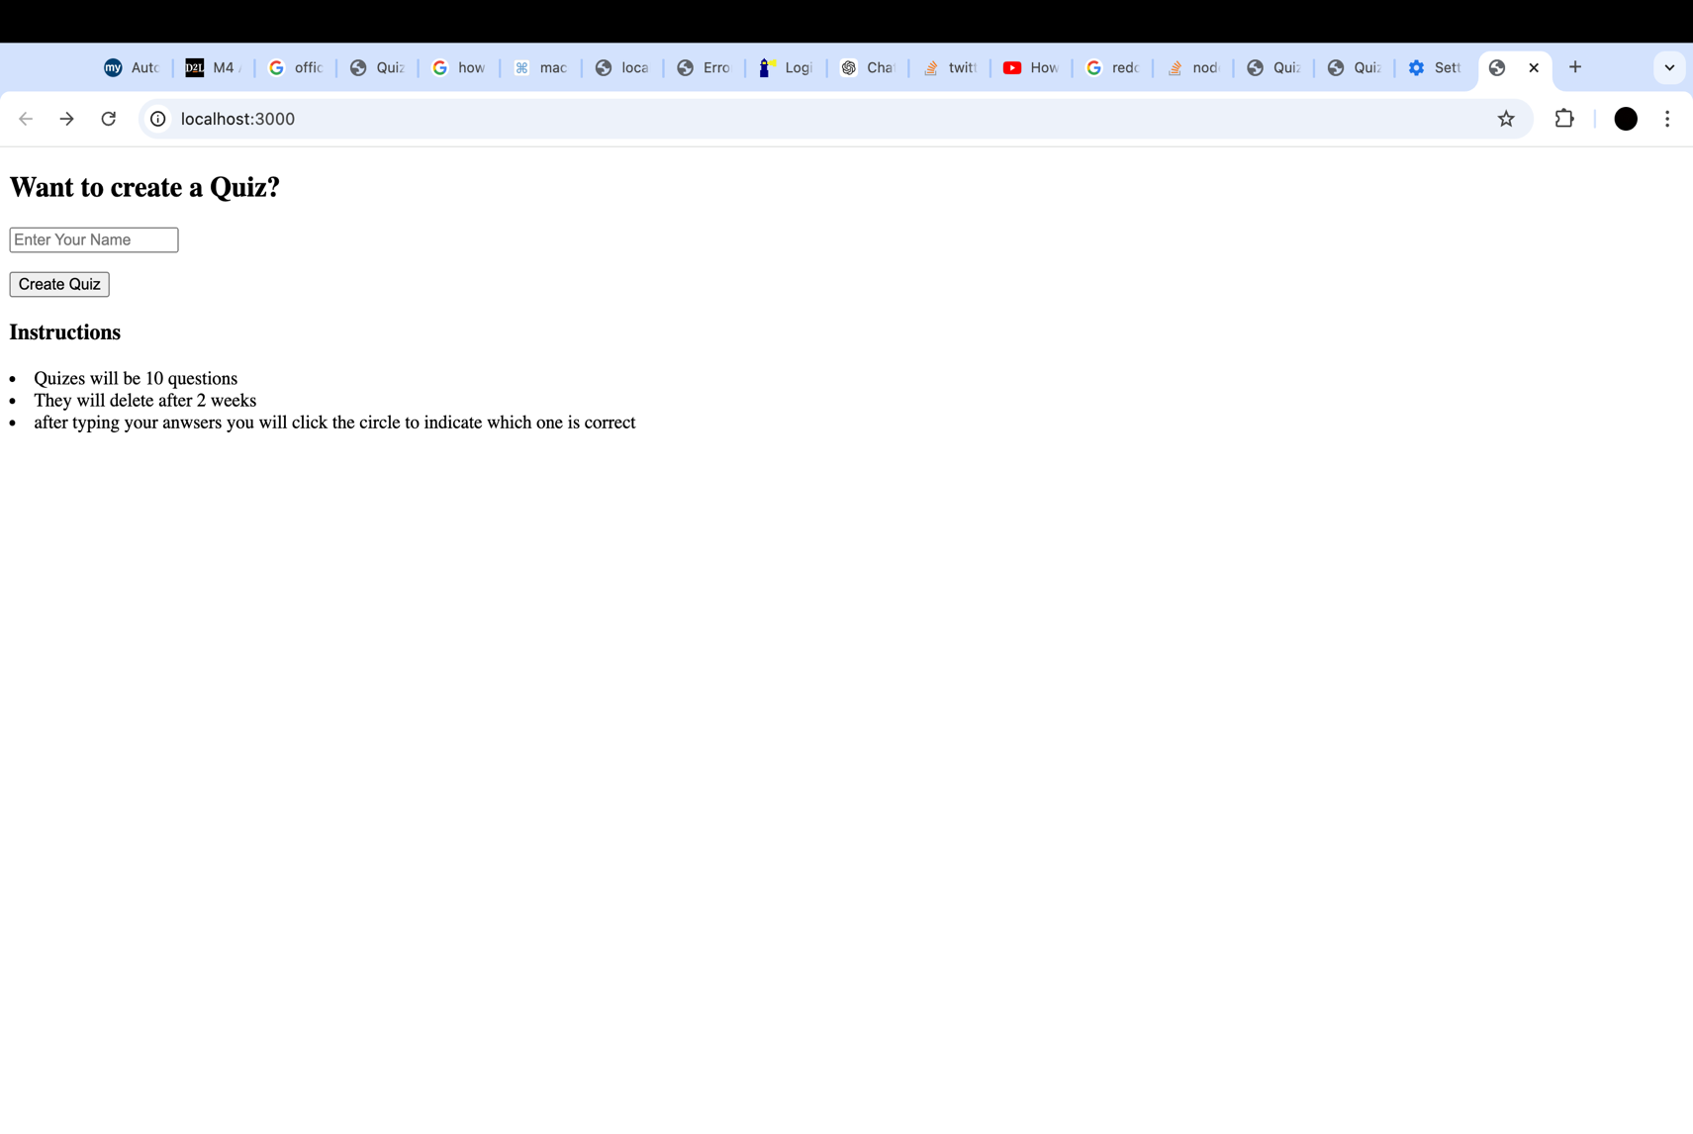When uploading the file ../public/namepage.js was needed since the public was already initiate this is all that is needed





At the top you can see it running on local host with the name Anthony being the one to create the quiz this shows that it is running on the server that has been created

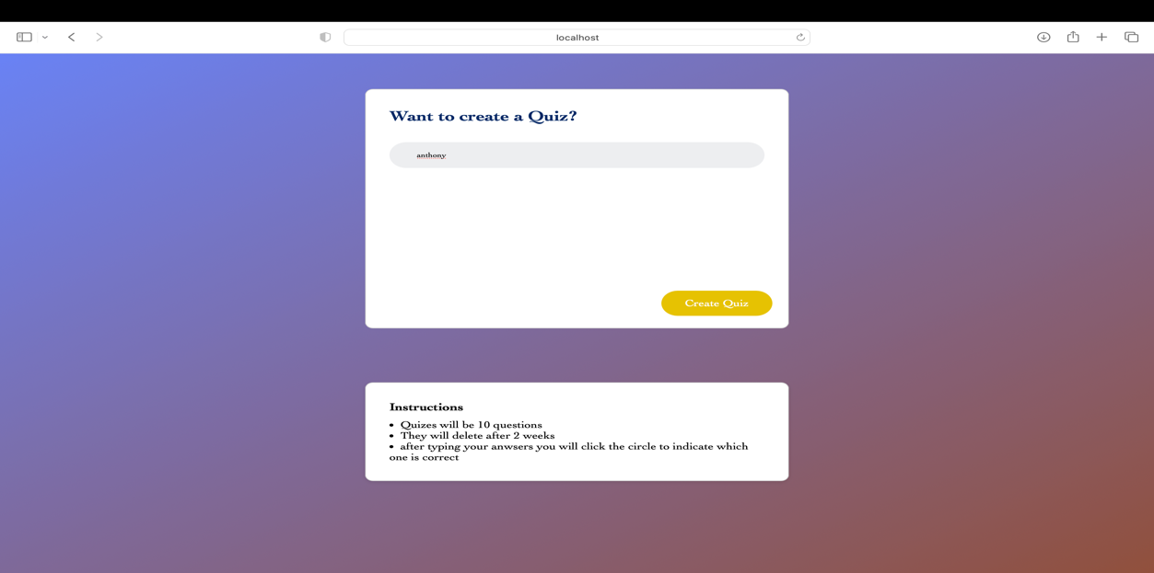



This adds a connection to the index file. So now once I click create quiz it goes to quiz creation.

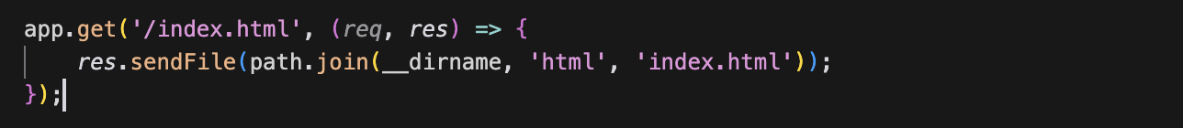

In the table created called quiz creators The name Anthony. Was added through the server on the local host. There are two because of the initial test I did solo.

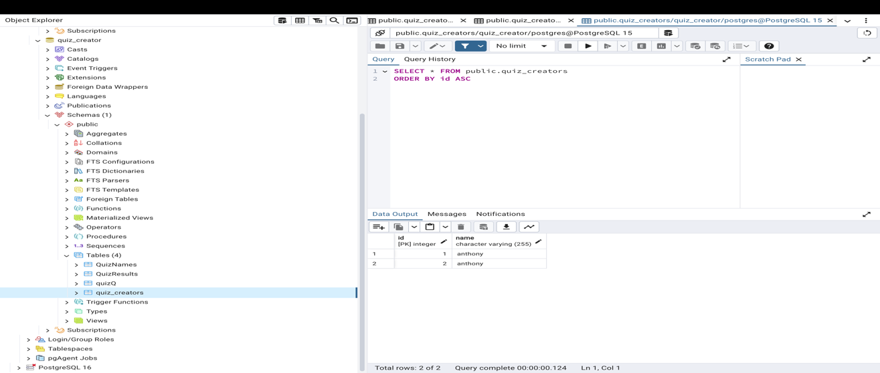



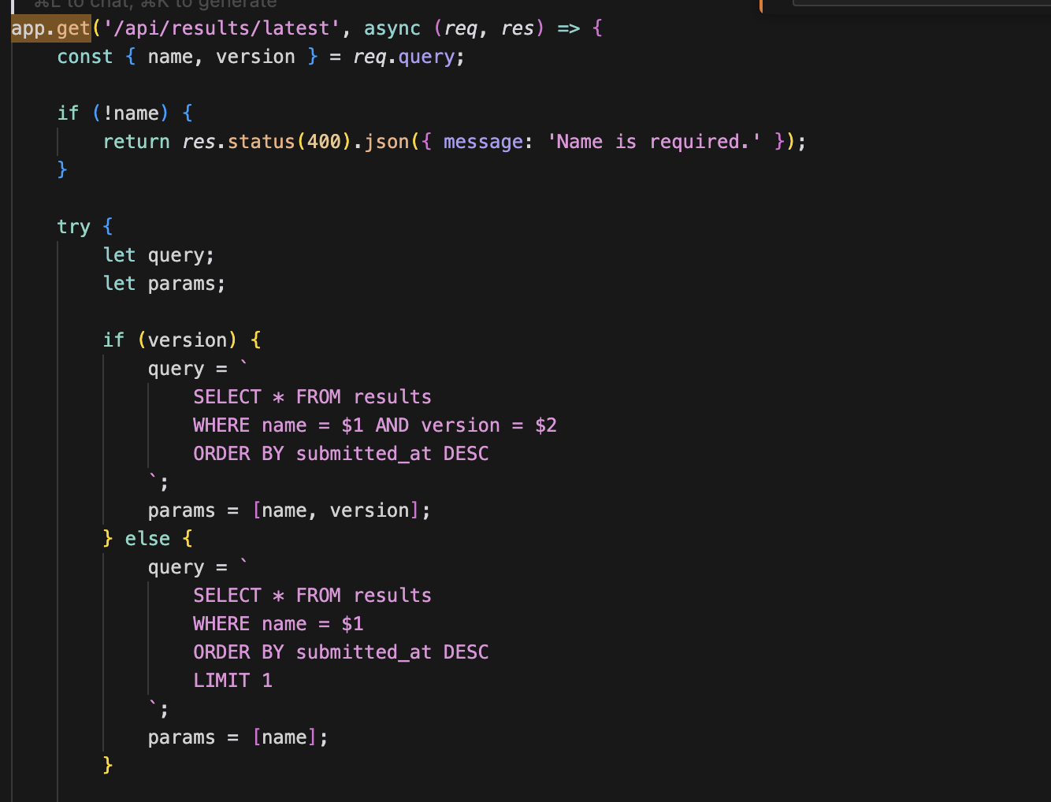

This code fetchs the most recent test results for a user (by their name) If no results are found, return an appropriate error message

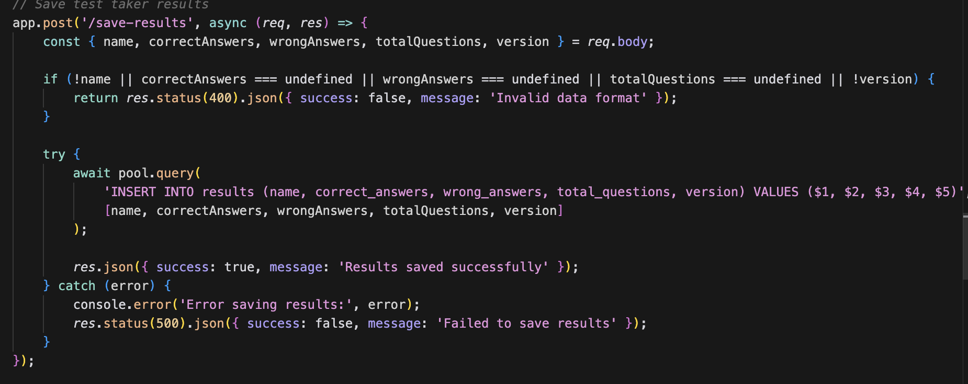

This code saves the results with the first and last name as well as the total correct and incorrect answers and the quiz that was taken

## Database

Download postgres sql   
 There will be information that needs to be remembered like sql password

Create a database for all quiz info that needs to be saved

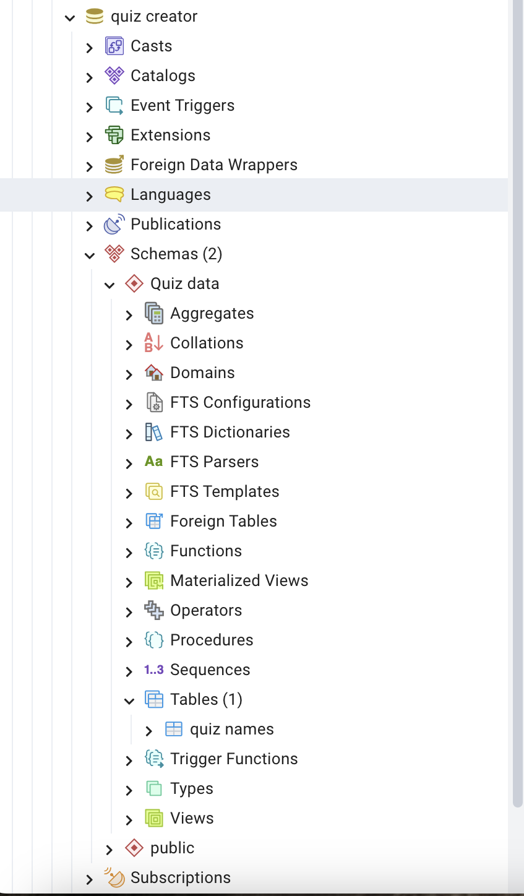

Create tables to save data like the name of the person creating the quiz. The quiz results and the actual quiz this will prepare the database for the saved data that will come from the fully created quiz it is also what will be pulled from so people that want to can take the quiz

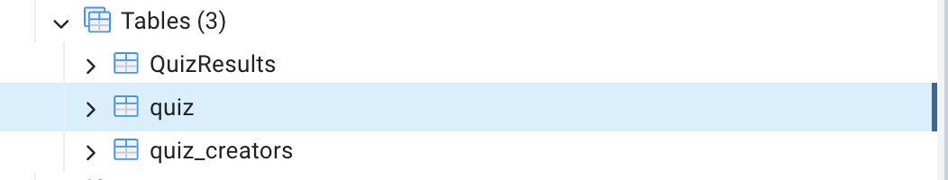

This is the table used to save an array of answers the correct answer and the question.

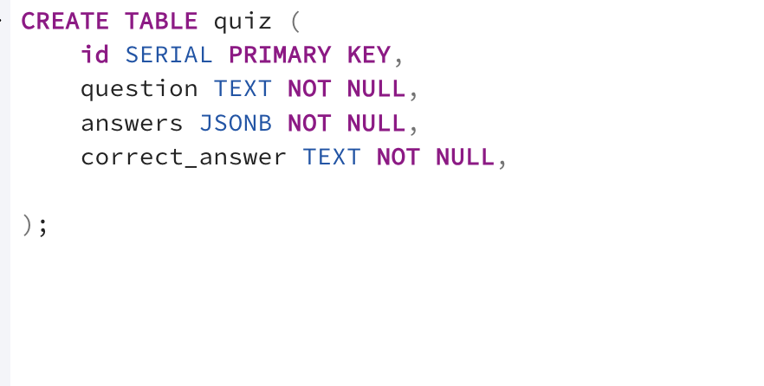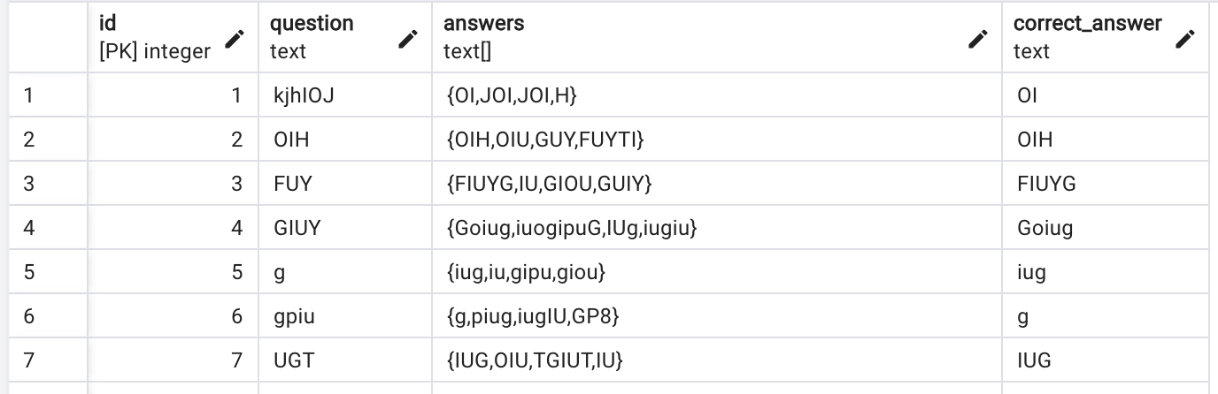

Add is true When adding is true you can use code to search the database for anything that is_new meaning my first few questions

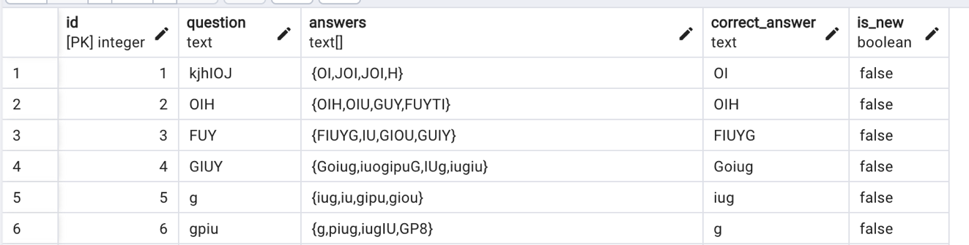  
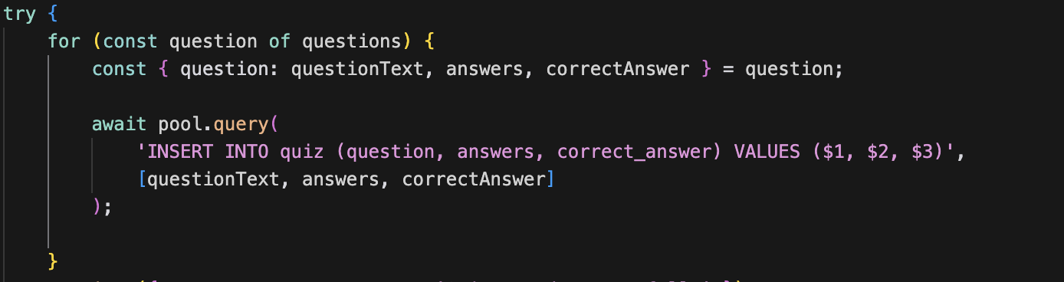

### Saving questions and answers to the database

### React recreation

npx create-react-app myapp

cd myapp  
these two lines of code need to be put into the terminal   
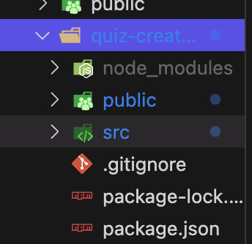  
it will create files that you can use for your react project and some of the files just need simple file changes.  
  


this file imports react from the terminal  
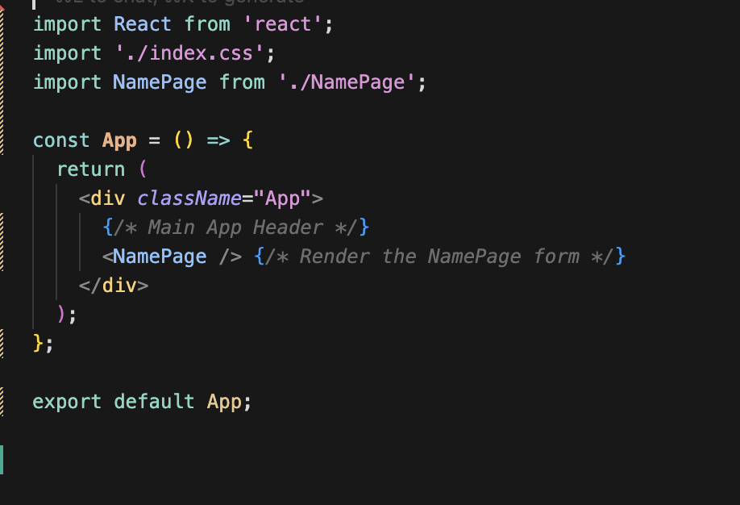  
  
  
If you ever have any issues react will automatically show you what the issue is and where it can be found on the webpage and terminal  
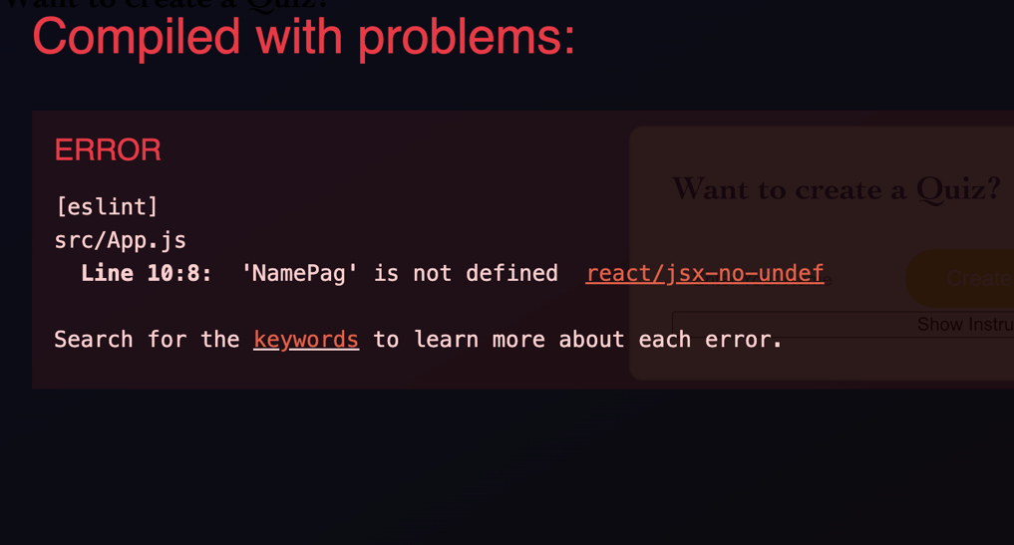

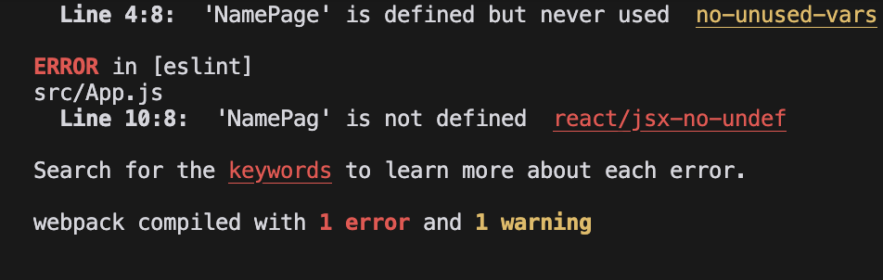  
  
  
 After putting adding react to my previous namepage.js file I was able to have a show instructions button that dropdowns and shows said instructions.

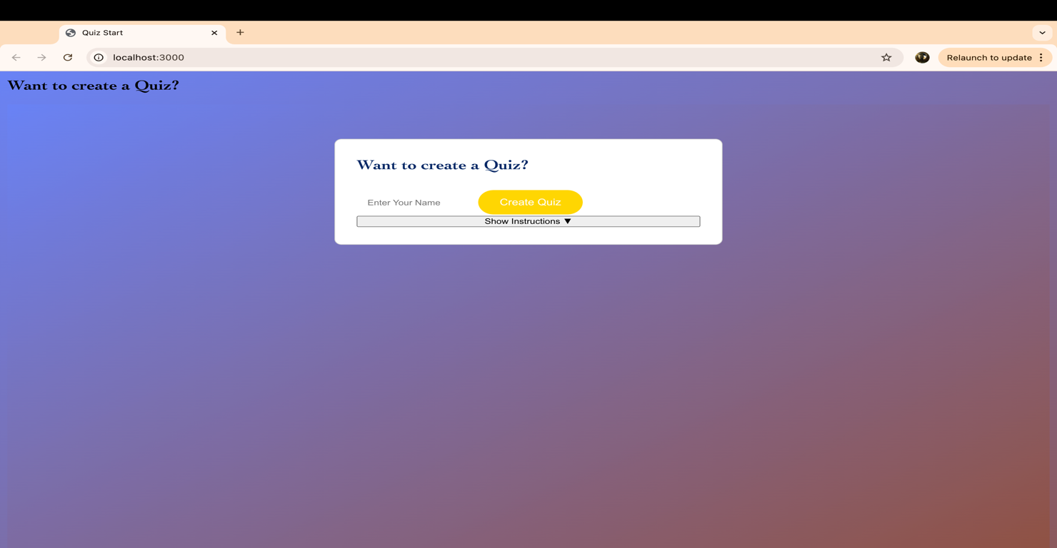  
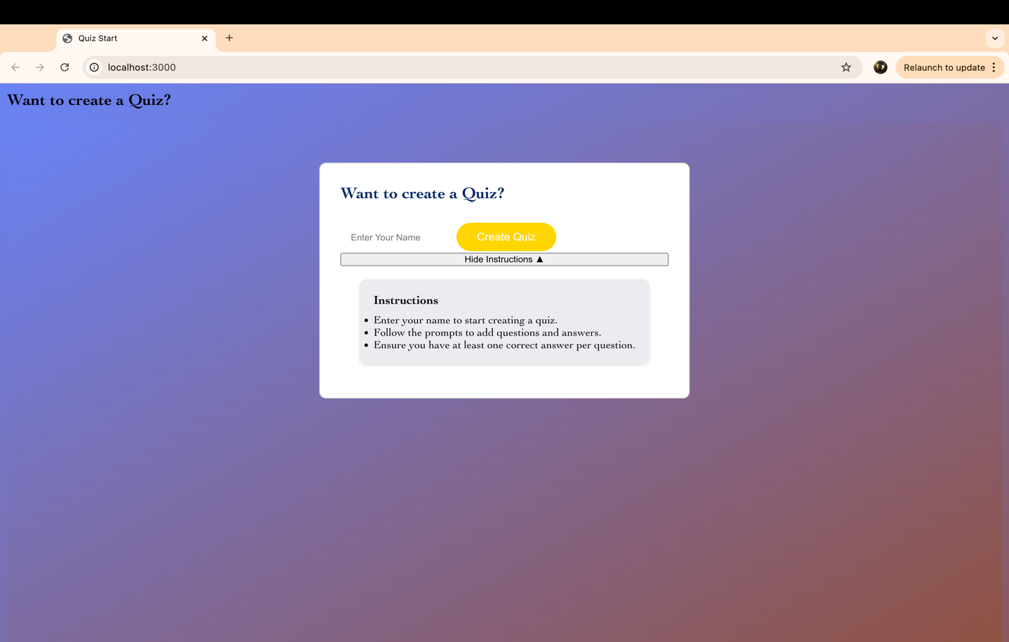

Webpage playthrough  
first we come up with a name   
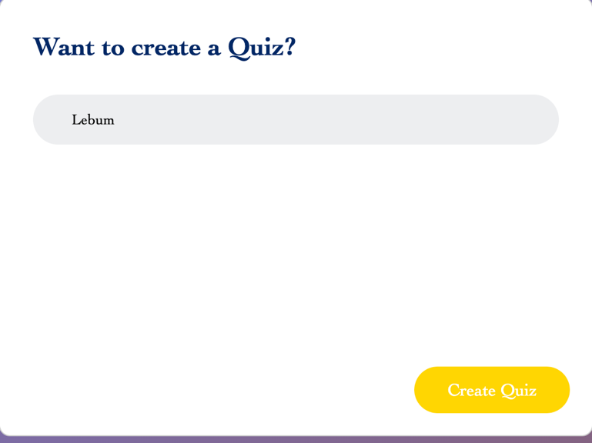

Next we create the quiz questions and answers while clicking on which answer is correct  
  
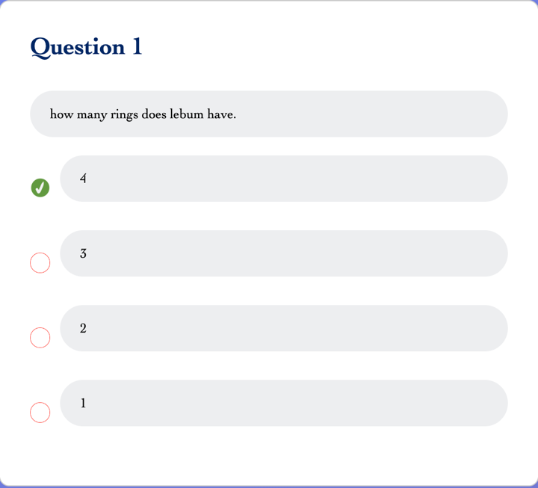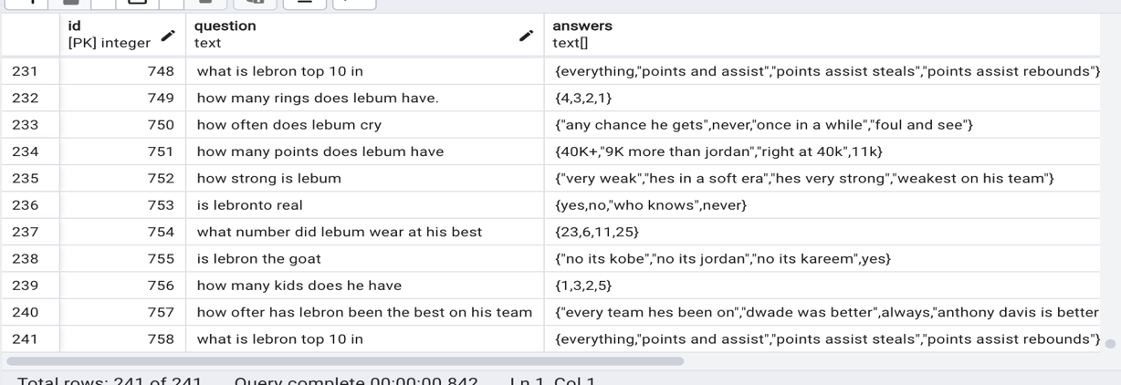

Heres the database that the quiz information went to

Next we right click take test an open up a new tab with the link  
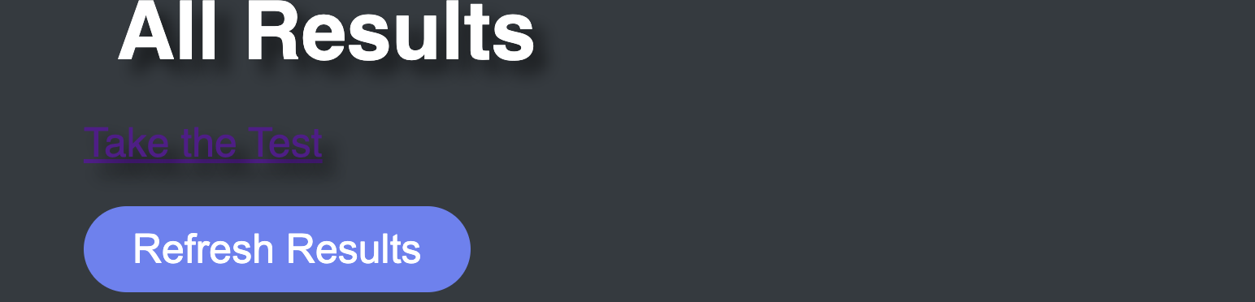  
  
With this new link other can take the test don’t forget to enter a name  
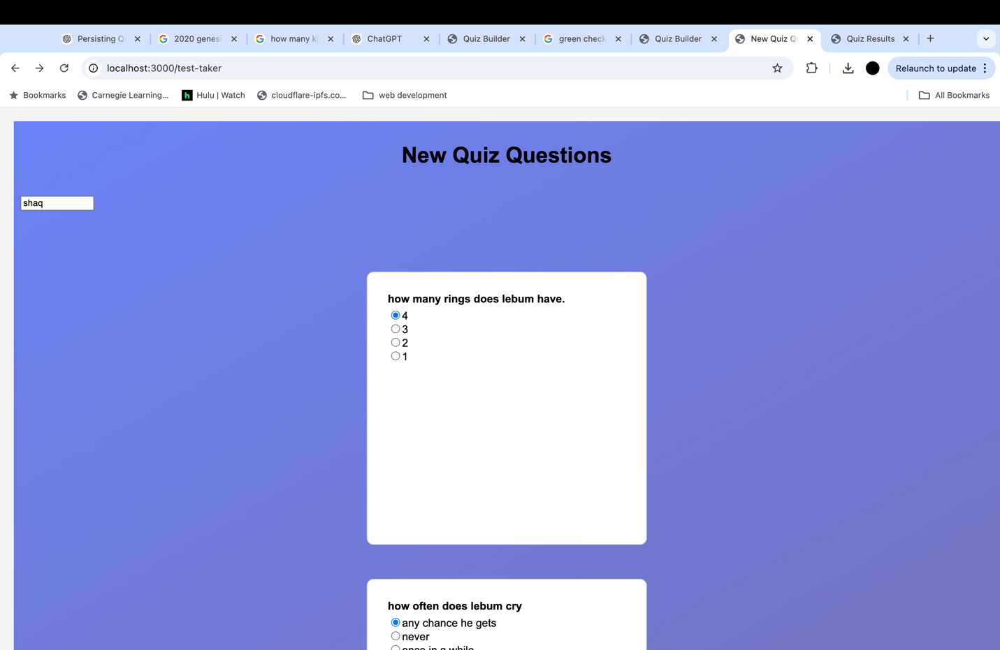  
After that they will get their test results and they are done  
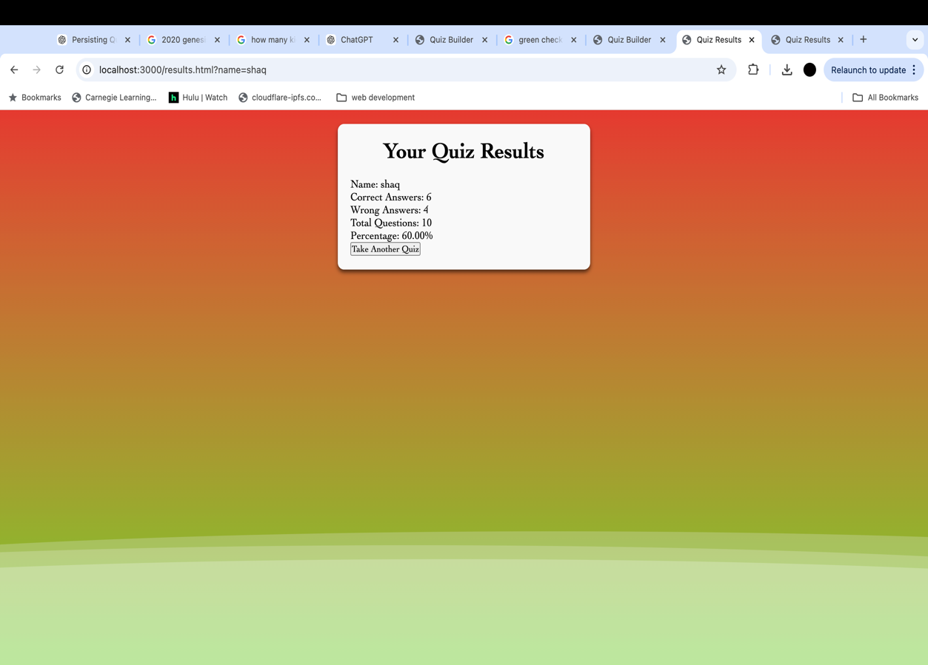

When they are done with the test click refresh and you will see the quiz they took send the link again to others and more results will populate  
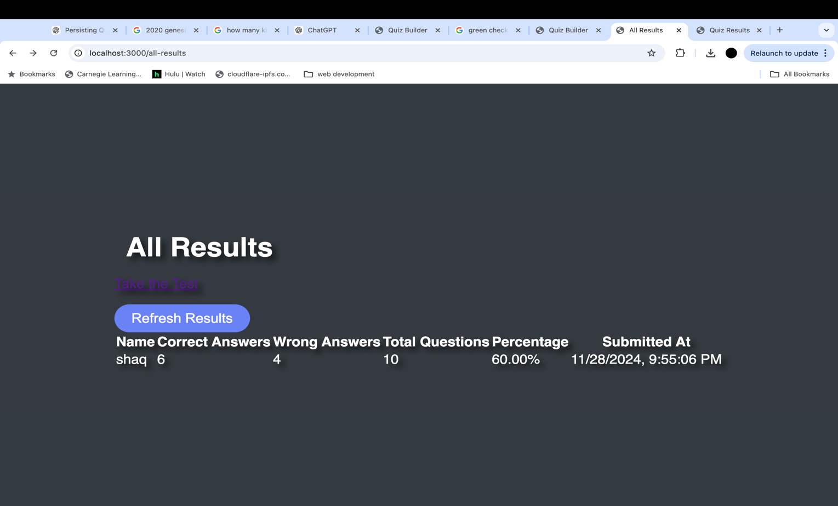

## A screenshot of a computer Description automatically generated shaqs name is at the bottom and is the only test grade shown within the database because he is the only one to take the quiz created by “LeBum” Roadblocks

### Questions not adding

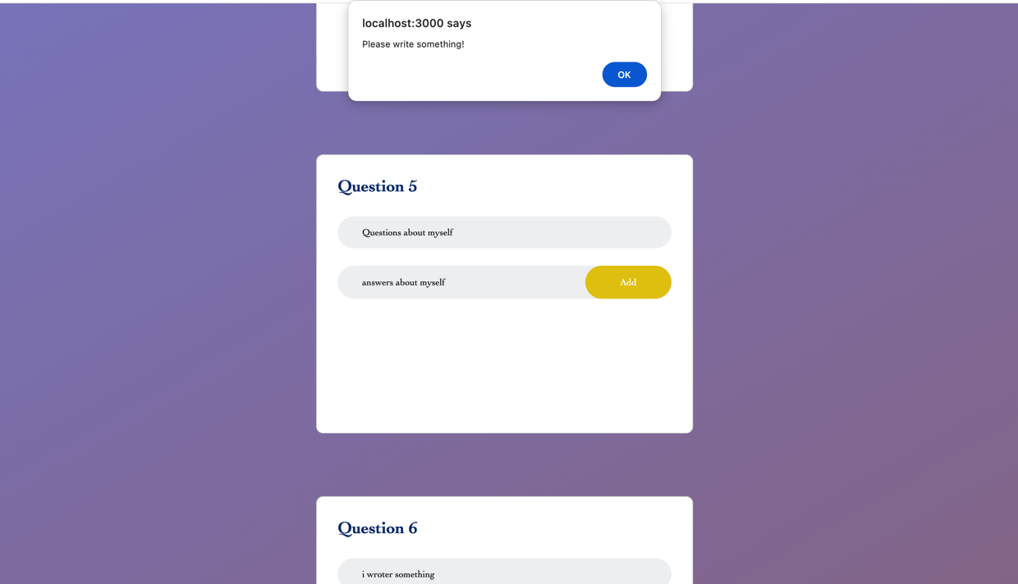

When typing in an answer past question 2 my inputs were not taken, and I got the error message please write something even though something was there.

Resolution to questions not adding

What I did to fix this was simple

Due to copying and pasting each task had the same function name causing the issue. After numerically fixing them the problem was solved

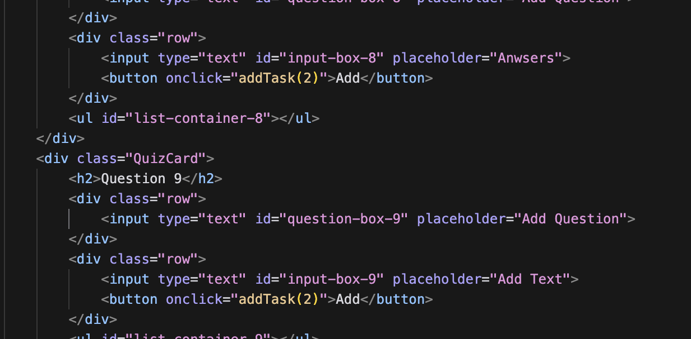

### Struggling to entire question card to a database.

When trying to save quiz questions answers and correct answers to a database in a similar way to how I saved my name inputs I struggles with it saving to the database.

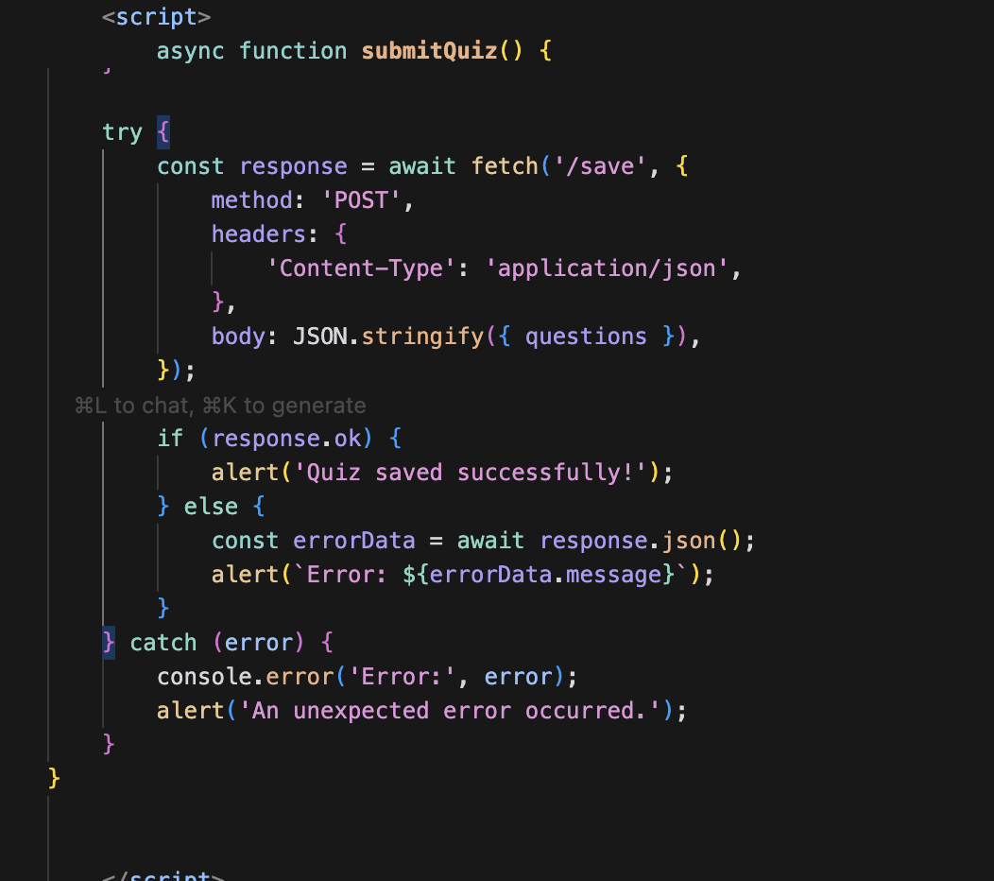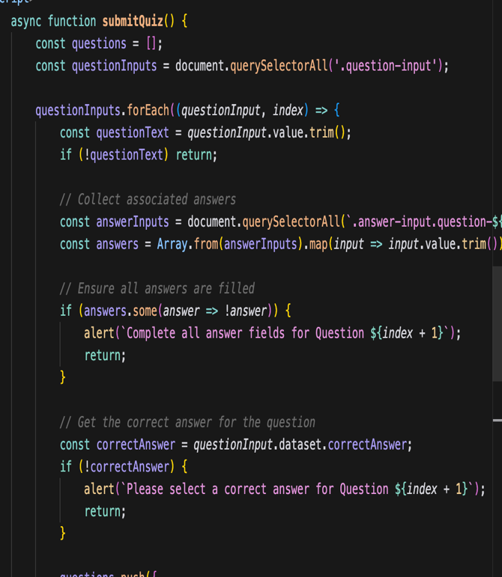

Question card saving resolution  
there wasn’t anything Wrong with my code the problem was with my database setup

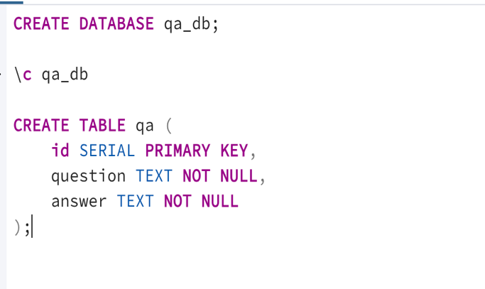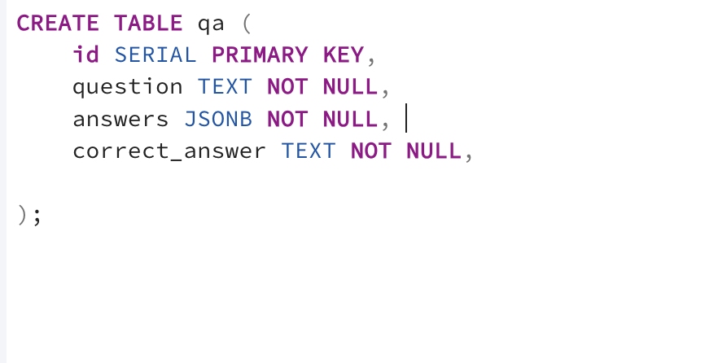

The picture on the right shows the correct way to set it up jsnob allows an array of answers to be saved and a correct answer column singles out the correct answer so that I can easily find it later.

Wrong Q&A being used   
after finally getting my question card to save to a database I wasn’t able to fetch the newly created data only old questions would pop up.

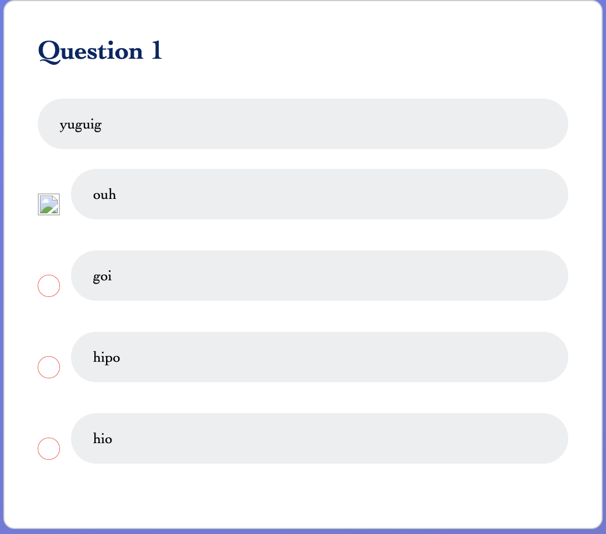

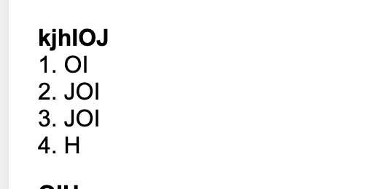

This is the first question in the test taker webpage Which is the first question ever put onto the database





Resolution

To solve this I had to create a new column called is_new this helps me define the newer questions and allows me to specifically pick the question that are is_new true.  


